|  |  |
| --- | --- |
| **Project Title** | Applied Degree in Software Engineering (BDSE) |
| **Qualification Name (NICF)** | Applied Degree in Software Engineering/ Higher Diploma in Software Engineering |
| **Product Name** | Meals on Wheels Web Application |
| **Module Name (NICF)** | Develop Enterprise Applications |

|  |  |  |  |
| --- | --- | --- | --- |
| **Student name** | | **Assessor name** | |
| Hewa Kondara Gamage Tharushika Nethmi Nilupulie | | Ms. Arvinder Kaur | |
| **Date issued** | **Completion date** | | **Submitted on** |
| 25June 2023 | 8July 2023 | | 8July 2023 |
|  | |  | |
| **Project title** | Develop Enterprise Applications | | |

|  |
| --- |
| **Learner declaration** |
| I certify that the work submitted for this assignment is my own and research sources are fully acknowledged.  Student signature: H.K.G.T.N.Nilupulie Date: 08-07-2023 |

Content

1. Project Background

2. Project Objectives

3. Project Requirement Specifications

4. Task 1

5. Task 2

6. Task 3

7. Task 4

8. Task 5

9. Task 6

10. Task 7

11. Task 8

**Task 1: Introduction**

* 1. **Project Background**

As a full-stack web developer team for Unity One Solutions, we are assigned to develop the “Meals on Wheels” project. Meals on Wheels is an online food delivery service platform managed by the charitable organization Merry Meal that provides hot noon meals to qualified seniors living at home who are unable to prepare their food or maintain their nutritional condition because of old age, illness, or disabilities. The service will be offered from Monday through Friday. And, who is more than ten kilometers away from their contracted kitchens, they will be delivered frozen meals throughout the week. Over the weekend, frozen meals will be delivered to all the members.

The Application should allow

• Members and Caregivers registration with their requirements

• Partners and Volunteers registration with their details

• Fundraising through Donors/Supporters

• Menu Planning and Preparation

• Meal Delivery Management of partners and riders

• Food Safety Management

• Reassessment of need evaluation, and,

• Management Information System for effective management

We will develop the project containing all the points in our notes. Our main focus will be making the ordering and delivery procedure simple for the aged, diseased, or disabled customer as well as for the business. Besides the system should be user-friendly with a dynamic menu, so that all the options can be easily visible.

The application will be developed using Spring Security for the backend, Restful Web Services for API, and React JS for the front end. Throughout the project development period, the adaptive software development method will be followed.

* 1. **Pain Points [Group)**

**Business problem statement:**

**The Offline Food Delivery System:**

• is difficult to manage and update the data and information.

• is challenging to meet consumer demands due to a lack of communication between the organization and the delivery partners.

• has a lack of responsiveness and customer support.

• is less interactive with the customers which leads to fewer customers reaching out to the restaurant

• is failed to maintain a proper food management system.

• is not able to provide proper training to the delivery men for handling orders, which sometimes mishandles the orders.

• cannot track delivery status and customer feedback.

• cannot arrange sufficient funds and online promotion.

• is not reachable for old and disabled people ordering food, if they live far away from the closest branch of our restaurant

**SWOT Analysis**

An organization's strengths, weaknesses, opportunities, and threats can be identified and analyzed using the SWOT analysis framework. The main objective of a SWOT analysis is to raise awareness of the variables that influence business decisions or the formulation of business strategies. The "Meals on Wheels" online food delivery system's SWOT analysis is a potent analytical tool that offers insight into identifying and seizing possibilities that can be used to develop and enhance the business operations of the organization. Additionally, as was already said in the above, the SWOT analyzes risks that draw management's attention to it and finds organized weaknesses that may be eliminated.

Let’s get straight deep into the SWOT one by one

The following provides an overview of key strengths, weaknesses, opportunities, and threats associated with Merry Meal.

**A. Strengths**

i. The company has special resources and inexpensive resources.

ii. The market views the company's activities and resources as its strength.

iii. Online application can save a lot of time than a manual

iv. Unique delivery proposition of the company

v. Compared to the manual system, the online system also aids in managing application user information.

**B. Weaknesses**

i. Competitor behaviors that can be viewed as weaknesses

ii. Mistakes to avoid when using the online buying system

iii. The application could be improved in terms of potential bugs in the future and other risks.

iv. Factors that can reduce the sales

**C. Opportunities**

i. Fascinating industrial trends

ii. Modifications to market tactics and technology

iii. Competitor behaviors that can be viewed as weaknesses

iv. Modifications to government regulations that affect the business sectors

v. Modifications in social norms and way of life

**D. Threats**

i. Competitors' activities

ii. Issues with the financial cash flow

iii. Threat posed by evolving technology

iv. Standards for the quality of goods and service

**1.3.1. Project Objectives**

The objectives of “Meals on Wheels” Online Food Delivery system is:

• to manage the food item's data, the category, the customer, the order, the confirmation of the order, and the order's 10-kilometer delivery radius.

• to create a software application that will lessen the manual work required to manage the food item, category, and fund-raising clients.

• to keep track of all the customer's information, the order's confirmation information, and the order's 10-kilometer delivery radius.

• to effectively and thoroughly assess customer needs, a fully automated system that not only saves a great deal of time but also provides quick and food service.

**1.3.2** **Project Goals**

The "Meals on Wheels" project's goal is to offer a comprehensive solution for the food delivery system. As well as make the food delivery system more efficient. Every service must be accessible from Monday through Friday. The other goal of this project is to keep track of all the details regarding the food item, fundraising, assurance of food safety, confirmation of orders, 10-kilometer delivery radius, meal planning, and customer delivery status. Since the project will be entirely built at the administrative end, access will be solely guaranteed for the administrator.

* + 1. **Project Scope**

By transforming the traditional "Meals on Wheels" system from a manual process, where customers had to personally visit the nearest restaurant branch to place food orders, we have successfully developed a web-based project called "Meals on Wheels." This project aims to automate the food delivery system operated by a charitable organization, which prepares and delivers hot noon meals to eligible adults who are unable to cook for themselves or maintain proper nutrition due to age, illness, or disability.

The "Meals on Wheels" web application will streamline essential operational tasks such as user registration, login functionality, order placement, food delivery management, fundraising activities, ensuring food safety, maintaining maintenance details, handling meal planning and delivery, managing stock details in the warehouse, and maintaining employee information, among others.

**Task 2: Project initiation**

* 1. **Project Stakeholder**

2.1.1 Sponsor of Merry on wheels’ application

2.1.2 Mr. David Project manager of Unity One Solution

2.1.3 Member of Merry meals charity organizations as a client

2.1.4 Merry meals project team’s member

**2.2 Feasibility study –at application level(Group)**

**2.2.1 Technical Feasibility**

The "Meals on Wheels" project is dedicated to developing an efficient online food delivery system. To bring this vision to life, we have chosen a blend of powerful technologies including Spring Boot and REST API, React JS. By harnessing the capabilities of these technologies, we aim to create a seamless and user-friendly application.

Our comprehensive solution will encompass various essential features such as user registration, login functionality, streamlined order management, and efficient food delivery services. With all these components integrated into a single platform, users will experience enhanced convenience compared to traditional manual food delivery systems.

Embracing web technology, we are launching this project as a web-based application, ensuring its accessibility to a wide range of users. This approach enables us to cater to a larger audience and provide them with a convenient online food delivery experience.

Through the utilization of the aforementioned technologies and our commitment to user satisfaction, we strive to revolutionize the way food delivery is managed. Our goal is to create a robust and user-friendly online food delivery system that will redefine convenience and streamline the entire process for our valued users.

**2.2.1.1. Familiarity with application**

To ensure the success of the "Meals on Wheels" project, it is crucial for the development team to be familiar with the application domain. This includes understanding the requirements and challenges specific to the Meals on Wheels online food delivery system. The team should have a clear understanding of user expectations, industry standards, and best practices in food delivery.

**2.2.1.2. Familiarity with technology**

Familiarity with technology refers to the level of knowledge and expertise that the development team possesses in the chosen technologies for the project. In the case of the "Meals on Wheels" project, familiarity with technologies like Spring Boot, REST API, and React JS is important. The team should have experience working with these technologies, understanding their features, capabilities, and best practices for development. Familiarity with technology ensures that the team can effectively utilize the chosen technologies to build a robust and efficient online food delivery system.

**2.2.1.3. Project Size**

Determining the exact project size for the Meals on Wheels food delivery system web project using Spring Boot and React JS would require a detailed analysis of the project's requirements and scope. However, we are providing a general estimation of the project size based on common Depending on the below specific requirements of the project:

* Member Management:
* User registration and login functionality
* User profiles and preferences
* Address management for delivery
* Partner Management:
* Partner profiles and menu management
* Order management and tracking for partners/restaurants
* Integration with payment gateways for online transactions
* Order Management:
* Shopping cart functionality
* Order placement and confirmation
* Order history and tracking
* Notifications for order status updates
* Delivery Management:
* Integration with mapping APIs for address geolocation and route planning
* Assigning delivery personnel to orders
* Tracking delivery status and estimated arrival times
* Admin Dashboard:
* Admin login and role-based access control
* Partner, delivery and menu management
* User and order management
* Analytics and reporting features

Based on these components, the project size of Meals on Wheels can be categorized as medium to large, considering the complexity involved in implementing features like real-time order tracking, payment integrations, and user management. The development effort can typically range from one month depending on the 6 member’s team's size and the project's specific requirements.

**2.2.1.4. Hardware, Software and Network requirement**

The "Meals on Wheels" project will require specific hardware, software, and network infrastructure to ensure its technical feasibility. Here are some general requirements to consider:

**Hardware Requirements:**

* Servers or cloud infrastructure capable of hosting the web-based application.
* Sufficient storage capacity to store user data, order information, and food inventory.
* Adequate processing power to handle concurrent user requests and perform computations efficiently.
* Network infrastructure with reliable internet connectivity to support online operations.

**Software Requirements:**

* Spring Boot: The chosen technology for developing the back-end of the application. The development team should be familiar with Spring Boot and its associated tools and frameworks.
* REST API: The application will expose RESTful APIs to facilitate communication between the front-end and back-end systems.
* React JS: The chosen technology for building the user interface of the web application. The development team should have expertise in React JS and related libraries.

**Other software requirements may include:**

* Relational database management system (e.g., MySQL) for data storage.
* Security measures to protect user information and ensure secure communication (e.g., encryption, SSL certificates).
* Deployment tools for continuous integration and deployment (e.g., Docker, Jenkins).
* Version control system (e.g., Git) for collaboration and code management.

**Network Requirements:**

* Sufficient bandwidth to handle user requests and data transfers.
* Firewall and network security measures to protect against unauthorized access and attacks.
* Integration with third-party services such as payment gateways and mapping APIs, which may require specific network configurations.

**2.2.2 Operational feasibility**

Operational Feasibility is a key aspect of the "Meals on Wheels" project, as it focuses on providing customers with convenient access to hot meals and an extensive menu selection for ordering. By leveraging this application, the organization can efficiently manage incoming orders and track the progress of deliveries.

The primary objective of this project is to streamline the operational processes involved in meal provision. Through the application, customers can easily browse the available dishes and place their orders, ensuring a seamless and user-friendly experience. This not only enhances customer satisfaction but also enables the organization to effectively manage and fulfill customer requests.

By implementing this solution, the organization gains operational efficiency and improved control over the meal delivery process. It enables efficient order management, reducing the chances of errors and delays. The application serves as a centralized platform for managing orders, ensuring timely deliveries, and maintaining a high level of customer service.

In summary, the "Meals on Wheels" project prioritizes operational feasibility by offering customers the convenience of accessing hot meals and a diverse menu through a user-friendly application. The application streamlines order management and delivery processes, enhancing the overall efficiency and effectiveness of the organization's operations.

**2.2.3 Economic feasibility**

The economic feasibility aspect of our project, "Meals on Wheels," plays a crucial role in understanding the budget requirements and potential income generation upon its release. In this case, we have determined that the necessary budget for the project is relatively low. One of the primary factors contributing to this is the utilization of free-to-use technologies, which significantly reduces development costs.

Considering that our application is part of a charitable organization, its creation will not incur substantial expenses. Our objective is to provide meal services to individuals facing economic challenges, making it a cost-effective and convenient solution for them. As a result, the application aligns with the organization's mission and serves its purpose effectively.

To ensure sustainability and maintenance of the application, we will charge a nominal fee to customers. This fee will contribute to covering ongoing expenses and support the continuous availability and improvement of our services.

Overall, the economic feasibility analysis affirms that the "Meals on Wheels" project is viable within a limited budget. It leverages cost-effective technologies, aligns with the charitable organization's objectives, and incorporates a small customer fee to support ongoing maintenance and improvements.

**Cost Benefit Analysis**

* **Cost analysis**

|  |  |  |
| --- | --- | --- |
| List of cost needed | Description of activity | Total cost in month |
| Requirement gathering | conducting market research, and identifying user needs, gathering and documenting the project requirements | $100 |
| Hardware | servers, storage devices, networking equipment, and related expenses | $1000 |
| Software | Spring Boot, React.js, postman (all are free software) | $100 |
| Hosting | Go Daddy (Cloud hosting) | $100 |
| Maintenance | maintenance, updates, and bug fixes, monitoring, security measures, and regular backups | $100 |
| Design Implementation | UI/UX design, graphic design, and frontend development using React.js | $300 |
| Human resource | salaries for the development team | $1000 |
| Marginal / urgent cost | for unforeseen expenses or urgent requirements that may arise during the development and deployment process | $100 |
| Total cost |  | $2800 |
| Total cost expected |  | $3000 |

* **Benefit analysis**

|  |  |  |
| --- | --- | --- |
| Benefit gotten |  | Const / Month |
| Direct benefit | By increasing donation amount (earlier it was $1000, now it is $4000), saving cost, improving customer experience, expanding reach, we can get direct benefit. | $4000 |
| Indirect benefit | Brand visibility and recognition, by offering an easy-to-use website customer retention will increase, by using website data and analytics, data-driven decisions making will be easy for marketing; menu planning; and business growth. Overall performance benefit was $100, now it is $400. | $400 |

* **Return in investment**

$ROI=\frac{(Total value-total cost)}{total cost}*100\%$ = $\frac{(4400-3000)}{3000}*100\%$ = 46.66

**2.2.3.1 Direct Cost and Benefit**

Direct costs refer to the expenses associated with developing and maintaining the "Meals on Wheels" project, while direct benefits are the tangible and intangible advantages gained from its implementation. Here are some insights:

**Tangible Costs:**

* Development costs, including salaries of the development team.
* Infrastructure costs, such as servers, cloud services, and network resources.
* Licensing fees for third-party software or services.
* Marketing and promotion expenses.
* Maintenance and support costs.

**Tangible Benefits:**

* Increased revenue through online food orders and delivery.
* Cost savings by streamlining manual processes and reducing labor.
* Improved customer satisfaction and loyalty.
* Potential for growth and expansion.
* Competitive advantage over traditional food delivery services.

**Intangible Costs:**

* Time and effort required for learning and adopting new technologies.
* Potential disruptions during the transition from manual processes to an online system.

**Intangible Benefits:**

* Enhanced brand reputation and customer perception.
* Increased efficiency and productivity.
* Access to customer data for targeted marketing and business insights.
* Flexibility and convenience for users.
  + 1. **Schedule feasibility**

Schedule feasibility refers to the likelihood of completing the "Meals on Wheels" project within the desired timeframe. It involves analyzing the project's scope, available resources, and development timelines. Key considerations for schedule feasibility include:

* Adequate planning and allocation of resources to meet development milestones.
* Realistic estimation of development time for each feature and component.
* Identification and mitigation of potential delays or obstacles.
* Regular monitoring and adjustment of the project timeline based on progress and feedback.
  + 1. **Risk Feasibility**

Risk feasibility involves identifying and evaluating potential risks and their impact on the project's success. Some possible risks to consider for the "Meals on Wheels" project include:

**Security Risks:**

* SQL injection attacks and other vulnerabilities in the application.
* Unauthorized access to user data or payment information.
* Mitigation: Implement robust security measures, such as input validation, encryption, and secure coding practices.

**Maintenance Risks:**

* Failure to conduct regular maintenance activities, leading to performance issues or security vulnerabilities.
* Mitigation: Establishing a weekly maintenance schedule, including updates, patches, and bug fixes, to ensure the application's stability and security.

**Integration Risks:**

* Challenges in integrating with third-party services, such as payment gateways or mapping APIs.
* Mitigation: Thoroughly research and test integrations, consider fallback options, and establish contingency plans.

**Scalability Risks:**

* Inability to handle increased user demand or traffic during peak times.
* Mitigation: Plan for scalability by utilizing scalable infrastructure, load testing, and performance optimization techniques.
  + 1. **Legality Feasibility**

Legal feasibility is a crucial aspect of our project, "Meals on Wheels." We are committed to adhering to local data protection practices, ensuring that our data processing systems comply with all applicable legal requirements. In addition, we have obtained the necessary licenses, such as the FSSAI license, which guarantees the quality and safety of the food we deliver to our customers. Our team of skilled cooks undergoes rigorous training to ensure food safety throughout the preparation process.

Maintaining compliance with legal regulations is a top priority for our project, "Meals on Wheels." We are dedicated to following local data protection practices, ensuring that our data processing systems meet all legal requirements. Our commitment to legal feasibility extends to our food delivery system, as we have obtained the necessary licenses, including the FSSAI license, to ensure the highest quality and safety standards for the food we serve. Furthermore, our team of experienced and well-trained cooks guarantees the safe preparation of meals for our valued customers.

The legal feasibility of our project, "Meals on Wheels," is of utmost importance. We have taken steps to ensure compliance with local data protection regulations, implementing practices that safeguard the privacy and security of user data within our processing systems. Additionally, we have obtained essential legal documents, such as the FSSAI license, which verifies the quality and safety of our food offerings. Our highly skilled cooks undergo rigorous training, ensuring that the meals we provide meet the necessary legal standards for food preparation and handling.

In summary, legal feasibility is a critical aspect of the "Meals on Wheels" project. We prioritize compliance with local data protection practices and hold the necessary legal documents, such as the FSSAI license, to assure the quality and safety of our food delivery system. Our team's expertise and adherence to legal requirements ensure that we provide a reliable and legally compliant service to our customers.

* 1. **UI/UX Design Consideration** 
     1. **Menu Bar (Navbar)**

Easy website access is crucial for applications, and making the menu bar simple and recognizable accomplishes this.

Modern UI/UX design tends to employ straightforward but instantly identifiable symbols in menus and navigation to reduce the amount of extraneous text on the page. The theory behind this is that if symbols can be utilized to precisely and efficiently follow a clear path for the user throughout the website, it will improve the experience and cut down on the quantity of information that must be spent deciphering and making decisions on the screen.

* + 1. **Content**

There are numerous contents and information we have to put on the Meals on Wheels website. For adults, they are quite beneficial. A hot noon meal is prepared and delivered by Merry Meal to qualified adults who are living at home but are unable to maintain their nutritional condition owing to age, illness, or disability. A weekly updated dinner menu is available. Setting up a website requires creating fresh, high-quality material that is connected to the business and product.

* **Layout and design clarity**

The creation of a website requires a straightforward, appealing design. Consider simple, eye catchy font or typography, high quality images.

* **Functionality**

When considering functionality, there are a few factors to keep in mind including Login and registration. It is crucial to take into account the characteristics of our website from the perspective of the user. It's crucial to think about the website's performance and security features in relation to the needs of the business.

* **Responsiveness**

The most important aspect of modern design is responsiveness; Short Loading Time. When looking for information online, slow loading times irritate users and customers. Customers may be completely turned away due to this issue. Our website can identify loading speed problems through pre-testing. Before our website is formally launched, it can be fixed.

* **Short** **Loading** **Time**

Nothing irritates visitors more than slow loading times when searching for information. Customers may be completely turned away due to this issue. Our website can identify loading speed problems through pre-testing. Before our website is formally launched, it can be fixed.

* + 1. **Visual Design**
* **Unity**

Use this to create harmony between page elements so that they appear to belong together and users aren't distracted by chaotic (for example, misaligned) layouts.

* **Balance**

The use of color is crucial for drawing in clients. For the Merry Meal website, we went with a green-white-black color combination.

* **Contrast**

In addition to capturing attention, contrast can help focus the viewer's eye, highlight important information, and add variety or animations to a design.

* **Scale**

Typically, between 14px to 18px works well for web apps. While 14px can feel on the small side, it can improve the readability of weightier typefaces.

* 1. **Dependencies (Group)**
     1. **Logical dependencies**

In order to successfully complete our project, certain logical dependencies play a crucial role. These dependencies are essential components that need to be addressed:

* Complete Software Design Document with detailed specifications and architecture
* Complete Feasibility study to ensure the visibility and practicality.
  + 1. **Resource dependencies**

Resource dependencies are driven by specific constraints and factors that impact the project's execution:

* Meal availability is contingent on funding raised through donors or supporters.
* Sufficient funding can maintain the quality of the meals.
* Meal delivery depends on the volunteer's partner and rider.
  + 1. **External dependencies**

External dependencies are influenced by external factors and unexpected events that can impact the project's progress:

Unforeseen natural disasters or adverse weather conditions may occur, leading to potential delays in meal deliveries. It is important to be prepared for such circumstances and have contingency plans in place to mitigate their impact.

In the context of our project, "Meals on Wheels," understanding and managing these different types of dependencies is crucial. Logical dependencies such as the completion of the Software Design Document and the Feasibility Study are essential for project success. Resource dependencies, including funding availability and volunteer partnerships, need to be carefully managed to ensure the uninterrupted availability and delivery of meals. Additionally, being aware of external dependencies such as natural disasters allows us to proactively address potential challenges and maintain the smooth operation of our project.

* 1. **Project Assumptions (Group)**
     1. **Resources**

Possible resource will be taken in Merry Meals Application

* Human resource: Staffing the team with developers, designers, and support personnel, who will be working in Merry Meals
* Servers and Hosting: Infrastructure for hosting the website.
* Development Tools: Tools and software needed for the development.
* Database: Storage for user information, meal details, and order history.
* Payment Gateway Integration: Integration with a secure payment gateway.
* SMS and Email Services: Communication channels for order updates and notifications.
* Geolocation and Mapping Services: Integration of mapping and tracking services for deliveries.
* Security and Authentication: Measures to protect user data and ensure secure access.
* Customer Support and Communication: Tools for efficient customer support and communication.
* Analytics and Monitoring: Tools for tracking platform performance and user behavior.
* Human Resources: Staffing the team with developers, designers, and support personnel.
  + 1. **Finance**

Possible finance will be taken in Merry Meals Application

* Human resource budget for all Unity One Staff.
* Development Team:
* Salaries and wages for developers, designers, and other team members.
* Contractor or freelancer fees if hiring external resources.
* Software and Tools
* Licensing fees for development frameworks and libraries.
* Subscription costs for integrated development environments (IDEs) or code editors.
* Testing and debugging tools.
* Technology Infrastructure:
* Server and hosting expenses for development environments.
* Cloud storage costs for code repositories and project assets.
* Development Resources:
* Documentation and reference materials for the chosen technologies.
* Training or courses for team members to enhance their skills.
* Prototyping and Design:
* Expenses related to user interface (UI) and user experience (UX) design.
* Mockup and wire framing tools.
* Quality Assurance and Testing:
* Tools or services for automated testing.
* Costs associated with manual testing and bug fixing.
* Operations and Maintenance Costs:
* Regular platform updates and bug fixes
* Technical support and maintenance services
* Project Management:
* Project management tools or software.
* Communication and collaboration platforms for the development team.
* Miscellaneous Expenses:
* Utilities and office supplies
* Miscellaneous software subscriptions or tools.
  + 1. **Partner**
* Merry Meals food production complies to FSSC (Food Safety System Certification).
* Merry meals food has HALAL certification following halal regulation.
  + 1. **Project**
* Merry Meals Website will be conducted for further maintenance.
* SSL Certification to guarantee that.
* Backed up every day within 10 hours.
* Range of 1 month of work and for the testing will be conducted by its developer
  1. **Project Constraint(Group)**
     1. **Client**
  + Hot meals can be delivered within a radius of 10 KM.
  + Frost meals can be delivered above a radius of 10 KM.
  + Customers can place online food orders.
  + Hot meal service is only available every day except Saturday and Sunday.
  + Frost meal service is available during the weekend
  + Different ages of customers will be considered in developing the Merry on Wheels website in order to avoid misleading or misunderstanding stuff.
    1. **Time**

**•** Project Merry on Wheels website must be developed within a range of 1 month.

* + 1. **Scope**
* Scope of project for Merry on Wheels that has been settled before can’t be done if there’s budget / cost growth over calculated.
  + 1. **Cost**

**•** The free versions of all the applications are being utilized.

* + 1. **Resources**
* Limited software, technology, hardware and so on required
* Six people team will work on the hardware and software development process.
  + 1. **Environment**
* A convenient workplace requires for the developer teams.
* Team members must promptly communicate with clients and stakeholders.
  + 1. **Skill**
* The Java-skilled personnel allocated must also meet the project's skill requirements,
  + 1. **Man Power**
* Team members are proficient in Java, spring boot, React JS, Restful API.
  1. **Project Milestone: Progress to measure to achieve goals** 
     1. **Requirement gathering**

The Merry Meal project manager will speak with Merry Meal's employees and stakeholders to find out what they envision. After gathering the requirements, team will prepare a raw SRS document.

* + 1. **Validate expectations for requirements**

The raw SRS document will be delivered to the project manager. After validating all the requested requirements, team will set the objective, set the scope, prepare the final SRS document.

* + 1. **Predevelopment planning**

The project manager will assign each team member their task and duties once the requirements and development plan have been finalized.

* + 1. **Implementation**

This is the beginning of the project's development based on the predevelopment stage. Every team member will implement their assigned task.

* + 1. **Quality Assurance testing**

Each time a team's iteration is finished, quality control will be performed by the Meals on Wheels developer team. QAT (Quality Assurance Testing) begins when the team will believe that a build or integration has been completed as per the build map. During this stage, team members will conduct testing based on defined scenarios and business requirements. The purpose is to ensure that the build meets the specified requirements and functions as intended and any scenarios that fall short are revised until the functionality meets the standards. Once all testing scenarios are successfully completed and meet the standards, the implementation is considered internally complete. Subsequently, the project progresses to the User Acceptance Testing (UAT) phase.

* + 1. **User Acceptance testing**

UAT (User Acceptance Testing) refers to the testing conducted by the Meals on Wheels client to validate that the build aligns with the business requirements defined at the project's outset. It serves as a final check performed by the client after the internal team has already completed QAT. UAT is considered a subset of overall quality assurance testing, ensuring that the build meets the client's acceptance criteria before final implementation.

* + 1. **Deployment**

The deployment phase represents the final stage of the Meals on Wheels software development life cycle (SDLC), where the website will be transitioned into production. Once the project team has thoroughly tested the product and it has successfully passed each testing phase, it is deemed ready for implementation. This signifies that the product is prepared for real-world usage by end users.

The deployment process encompasses several distinct phases, which the project team will follow to ensure the smooth deployment of code and technology. These phases include preparing for deployment, executing the deployment procedures, transferring ownership of the product, and concluding the deployment phase.

* + 1. **Support**

After the project has been deployed, Merry Meal's developer team will continue to provide support for it for the predetermined amount of time.

* 1. **Project deliverables** 
     1. **Internal deliverables**

Within the project group, the following deliverables are identified:

**1. Web Design Proposal:** A comprehensive proposal outlining the design elements and user interface considerations for the Meals on Wheels web application. This proposal will serve as a blueprint for the visual appearance and functionality of the application.

**2. Software Design Document (SSD):** A detailed document that captures the technical specifications, architecture, and workflow of the Meals on Wheels web application. The SSD will provide a clear understanding of the software development process, including database design, modules, and integration points.

* + 1. **External deliverables**

The following deliverable will be provided to external stakeholders:

**1. Completed Meals on Wheels Web Application:** The final product of the project, a fully functional web application for online food delivery, will be delivered to external users. This application will allow customers to browse menus, place orders, and facilitate the delivery of hot meals to their doorstep.

* + 1. **Planning deliverables**

The planning phase of the project will involve the following deliverables:

**1. Project Scope:** A detailed description of the project's objectives, deliverables, and boundaries. The project scope will outline the specific features and functionalities that will be included in the Meals on Wheels web application.

**2. Budget:** An estimation of the financial resources required to complete the project. The budget will include costs associated with software development, hosting, marketing, and other relevant expenses.

**3. Project Schedule:** A timeline that outlines the key milestones, tasks, and dependencies of the project. The schedule will provide a clear roadmap for project execution, ensuring that activities are properly sequenced and resources are allocated efficiently.

These project deliverables are crucial for the successful development and implementation of the Meals on Wheels web application. They provide a structured approach to design, development, and project management, enabling effective communication and collaboration among the project team members and stakeholders.

* 1. **Functional description (Group)**

|  |  |  |  |
| --- | --- | --- | --- |
| No | User type | Description | Roles based access |
| 1 | Member | Ordering the food | * Register * Login * Order and view meal * Update profile, view meals track |
| 2 | Care giver/Drivers | Merry Meals support teams who help the members | * Register * Login * View all orders * Update meal delivery status |
| 3 | Partners | Preparing the food | * Register * Login * View everyday meal menu * View available delivery man * View meal delivery status |
| 4 | Volunteers | Participating in the Charity activity that’s done by Merry Meals Organization | * Register * Login * View Other member, donor, update profile |
| 5 | Donator / supporter | Donating money | * Register * Login * Donate money |
| 6 | Administrator | Managing all the activity including donation, member, menu, driver, administrative information | * Register * Login * Manage donation * Manage member * Manage menu / order * Manage driver * Manage information systems |

* 1. **Risk analysis and description (Group)**

**2.10.1. Identify possible area of risk in the application development**

* + - 1. **Internal risk**
* **Technology Risk**

Technology risk refers to the risks that can arise from using technology in a project. It includes the risk of technical failures, cyber-attacks, system breaches, and other problems that can impact the project's ability to achieve its goals. Effective management of technology risk involves:

-Identifying potential risks.

-Assessing their impact on the project.

-Implementing measures to mitigate and manage them.

This can include security protocols, redundancy measures, and contingency plans to ensure the project's success.

* **Schedule Risk**

The result of poor planning, schedule risk is the risk that project tasks and activities will take longer to complete than estimated. Schedule risk is closely related to cost risk because any slips in schedule often increase costs, slow down project benefits, and throw off timelines, which might lose any competitive advantage you might’ve had at the start.

* **Skill Resource Risk**

Skills resource risk in a project refers to the possibility that the project team may not possess the required skills, knowledge, or expertise to complete the project successfully. This risk can arise due to various factors, such as changes in project scope, unexpected technical challenges, resource availability, and turnover of key project team members.

* **Communication Risk**

Communication risk in a project refers to the potential for communication failures, errors or misunderstandings that could lead to delays, rework, or even project failure. This risk can arise from language barriers, cultural differences, technological limitations, or lack of clarity in messages.

* + - 1. **External Risk**
* **Political Risk**

Political instability, legal and regulatory constraints, tax regulations, product safety and environmental laws can be reasons for political risks to arise.

* **Natural Risk**

A natural hazard is the threat of an event that will likely have a negative impact. A natural disaster is the negative impact following an actual occurrence of natural hazard in the event that it significantly harms a community.

-Floodwater leakage into equipment’s

-Electrical grounding integrity/ Power cuts

-Drainage obstruction/washout

* **Economic risk**

Lack of funds that could be a result of inaccurate planning and managing the total estimation needed. Financial hazards and cyber-attacks can also be considered as risks.

* **Market risk**

Market risk includes risks posed from competition, commodity markets, interest rates, foreign exchange, and liquidity and credit risks. This project risk is more unpredictable and difficult to plan for, but there are ways in which project managers can protect their business.

* **Infrastructure risk**

Infrastructure risk is the potential for losses due to failures of basic services, organizational structures and facilities. These risks include under-provisioning or over-provisioning, hardware incompatibility, software incompatibility, network issues and outages, migration issues, downtime, disaster recovery, vendor reliability, and unexpected costs.

**2.10.2. Analyze and Evaluate**

|  |  |  |  |
| --- | --- | --- | --- |
| **No** | **Risk type** | **Risk description** | **Risk Impact** |
| **1** | Technological | Failure of hardware or software that can lead to data being lost or corrupted | Could delay the completion of project or sometimes can cause the project to fail if the data cannot be back upped. Therefore an alternative backup solution needs to be arranged |
| **2** | Schedule | Lack of resources that could arise due to poor planning will delay the completion of project | Ensure proper planning, gather all requirements and resources needed before the implementation of the project to avoid issues later.  If such issues take place, it could delay the time estimated to complete the project |
| **3** | Economic | Inability to manage funds as planned throughout the different phases of the lifecycle. | Financial management and proper planning needs to be done to avoid financial issues. Keeping a small amount separately to use in case of emergency can be wise. If not, raising funds again and managing them will delay the completion of project |
| **4** | Skills | Lack of knowledge or skills to handle problems or errors that can rise will affect the project implementation | Appointing team members with significant knowledge and skills on the role they would perform is crucial. Failure to do so, will Result in the overall failure of the project |
| **5** | Natural | Heavy rain fall or floods that can affect the workstation, or power cuts due to lightning and thunder could impact on the completion of project as per planned | Effects due to natural occurrences can breakdown the project and also cause delays in completing the project. Arranging safe workspaces for developers can be an alternative. |
| **6** | Political | One of the team members' governments banned one of the software or platforms. | If any software or platform used during the development phase is banned, the developer must find an alternative to the banned application and adapt and learn it all over again. This would also cause a significant delay in the project's progress. |
| **7** | Communication | Errors and misunderstanding due to language barriers, technological barriers and lack of clarity | There will be errors and issues in the project if the team members do not communicate and have a clear clarity on what needs to be done. Ensuring proper clarity of the project within team members will help avoid errors |

**2.10.3. Prepare Risk Matrix**

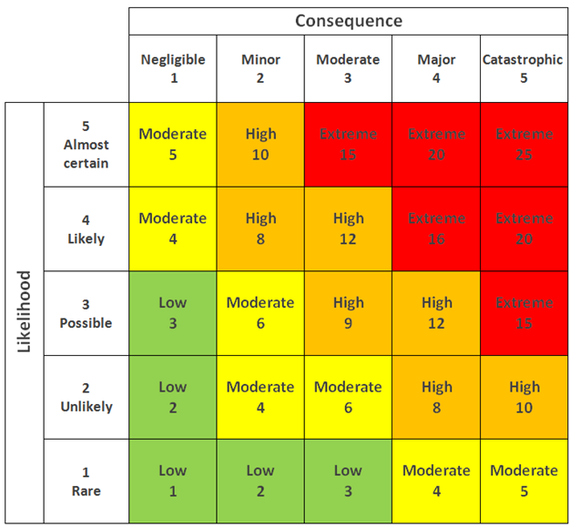

|  |  |  |  |  |  |  |
| --- | --- | --- | --- | --- | --- | --- |
| **No** | **Risk type** | **Risk description** | **Likelihood (1-5)** | **Consequence (1-5)** | **Risk rating** | **Risk level** |
| 1 | Technological | Poor quality code when developing application. When a project's quality does not meet stakeholder expectations, there is a significant risk that the project will fail. Poor quality code can occur for a variety of reasons, including project underestimation and developers rushing to complete iterations. | 4 | 5 | 20 | Extreme |
| 2 | Schedule | Due to poor planning and unclear requirements, project completion will have to be extended, which will impact the overall cost and advantages that could have been expected. | 3 | 4 | 12 | High |
| 3 | Economic | Inability to manage funds as planned throughout the different phases of the lifecycle. Sometimes the amount could be more than as what was planned. That can lead to insufficient funds needs to complete the project | 2 | 4 | 8 | High |
| 4 | Skills | Risk of being stuck half way due to insufficient skills and knowledge that is required for the successful completion of the project | 2 | 4 | 8 | High |
| 5 | Natural | Heavy rain fall or floods that can affect the workstation, or power cuts due to lightning and thunder could impact on the completion of project as per planned | 1 | 5 | 5 | Moderate |
| 6 | Communication | Communication failures, errors and misunderstanding due to language barriers, technological barriers and lack of clarity that could delay the project completion or sometimes lead to failures | 3 | 4 | 12 | High |
| 7 | Political | Banning of Certain software’s or apps that’s need for the development process in certain regions or countries due to political issues. | 2 | 3 | 6 | Moderate |

* + 1. **Risk Response Analysis**

|  |  |  |  |
| --- | --- | --- | --- |
| **No** | **Risk type** | **Risk description** | **Risk Response Plan** |
| **1** | Technological | In case of a technical issue, such as failure of hardware or software that can lead to data being lost or corrupted | Initiate alternatives for backups that can bring back lost or corrupted data |
| **2** | Political | One of the team members' governments banned one of the software or platforms. | Bypass from country or region restriction using various dedicated VPN or DNS |
| **3** | Economic | Insufficient funds to complete project due to lack of resources and requirements needed | Budget for the project keeping a small amount of funds aside without including into the plan, so that amount can be used in case of emergency of insufficiency |
| **4** | Natural | natural disaster that cause a lot of damage to the workstation and perhaps loose many human resources. | Create a safe physical workspace for team members to prevent minor disaster yet further to major disaster. Apply job insurance to sateholder’s contract |
| **5** | Skills | In case of a technical error, lack of knowledge or skills to handle the specific error can affect the project implementation | Appoint team members to perform specific roles as per their skills and knowledge so that they will be able to handle any problem that arises |
| **6** | Communication | Team members who are not well aware of what has to be developed due to lack of clarity or language barriers could make errors during the development | Make sure that all team members has a good clarity on the project by conducting meetings and asking them for their views on the project that has to be developed |
| **7** | Schedule | Lack of resources that could arise due to poor planning will delay the completion of project and will also have funds that will likely increase as the project gets delayed | Ensure proper planning, gather all requirements and resources needed. Have a check if all what is needed is ready before starting the implementation |

**Task 3: User and system requirements**

* **User Requirements**

|  |  |  |
| --- | --- | --- |
| No | Application Feature | Description |
| 01 | Multiuser Registration | The platform enables numerous individuals to log in and create accounts. These users can be categorized as members, caregivers, partners, riders, volunteers, donors, or administrators. Upon signing up and logging in, users gain access to their personalized dashboards to facilitate further actions and processes. |
| 02 | Fundraising through Donors/ Supporters | Users are provided with a wide range of online payment options, thanks to the integration of multiple payment channels. This feature aims to facilitate the collection of funds more effectively. The campaign page showcases upcoming campaigns, serving as a means to attract volunteers and generate financial support. |
| 03 | Meal Delivery Management and Partner & Rider Process | Partners can stay informed about the number of meals they have prepared on a daily basis, and this information can be conveniently displayed on their respective dashboards. Riders will receive the member's address and the partner's location, along with details about the specific meals to be delivered. Their role is to transport the meals to the designated locations (addresses). |
| 04 | Food Safety Management | Compliance with food safety regulations and obtaining relevant certificates is of utmost importance. A dedicated page containing information regarding food protection regulations and certificates will be accessible to all users. The link to this page will be prominently displayed on the homepage, allowing every user to easily access and view it. |
| 05 | Reassessment of need evaluation | This functionality enables members or caregivers to notify the administrator when they require assistance in the future. Additionally, they have the ability to provide feedback and write reviews, thus enhancing the overall user experience. |
| 06 | Management information system for effective management | The administrator has the authority to oversee the data of multiple users, effectively managing and maintaining it. Furthermore, they possess the capability to update the menu on a weekly basis, ensuring it remains current and up-to-date. |

**3.1. Software development lifecycle(SDLC):**

The software development lifecycle (SDLC) is the cost-effective and time-efficient process that development teams use to design and build high-quality software. SDLC provides a well-structured flow of phases that help an organization to quickly produce high-quality software which is well-tested and ready for production use. It aims to produce superior software that meets and exceeds all customer expectations and demands. Software development can be challenging to manage due to changing requirements, technology upgrades, and cross-functional collaboration. The software development lifecycle (SDLC) methodology provides a systematic management framework with specific deliverables at every stage of the software development process. As a result, all stakeholders agree on software development goals and requirements upfront and also have a plan to achieve those goals. The SDLC methodology focuses on the following phases of software development:

* Requirement analysis
* Planning
* Software design such as architectural design
* Software development
* Testing
* Deployment

**How does SDLC work?**

The software development lifecycle (SDLC) outlines several tasks required to build a software application. The development process goes through several stages as developers add new features and fix bugs in the software. The seven phases of SDLC are planning, requirement analysis, design, Implementation, testing, deployment, maintenance.

**Planning:** In the planning phase, project leaders evaluate the terms of the project. The planning phase typically includes tasks like cost-benefit analysis, scheduling, resource estimation, and allocation. The development team collects requirements from several stakeholders such as customers, internal and external experts, and managers to create a software requirement specification document. The document sets expectations and defines common goals that aid in project planning. The team estimates costs, creates a schedule, and has a detailed plan to achieve their goals.

**Requirement Analysis:**It is considered part of planning to determine what the application is supposed to do and its requirements. It also includes defining the resources needed to build the project.

**Design**: In the design phase, software engineers analyze requirements and identify the best solutions to create the software. Prototyping can be a part of a design phase. A prototype is like one of the early versions of software in the iterative software development model. It demonstrates a basic idea of how application looks and works.

**Implementation**: In the implementation phase, the development team codes the product. They analyze the requirements to identify smaller coding tasks they can do daily to achieve the final result.

**Testing**: Testing ensures that each function works correctly.  Quality analysis includes testing the software for errors and checking if it meets customer requirements. The testing phase helps reduce number of bugs. This leads to a higher user satisfaction and a better usage rate.

**Deployment**: In deployment phase, the application is made available to users. After the project team tests the product and the product passes each testing phase, the product is ready to go live. This means that the product is ready to be used in a real environment by all end users of the product.

**Maintenance**: The final stage of the cycle. The application is done and being used in the field. In the maintenance phase, the team fixes bugs, resolves customer issues, and manages software changes. In addition, the team monitors overall system performance, security, and user experience to identify new ways to improve the existing software.

* 1. **SDLC models: consider at least 4 models research:**
     1. **Waterfall model**
* **What is Waterfall Model?**

The Waterfall model — is a sequential development process that flows like a waterfall through all phases of a project (analysis, design, development, and testing, for example), with each phase completely wrapping up before the next phase begins. Project teams and [project managers](https://www.techtarget.com/searchcio/definition/IT-project-manager) use the waterfall model to achieve goals based on the needs of their business. The model is used in many different project management contexts, such as in construction, manufacturing, IT and software development. In the waterfall method, each step is dependent on the output of the previous step. There's a linear progression to the way these projects unfold.

* **Characteristic**
* Requirements are very well documented, clear and fixed.
* Product definition is stable.
* Technology is understood and is not dynamic.
* There are no ambiguous requirements.
* Resources with required expertise are available to support the product.
* The project is short.

* **Where we use it?**

This model is appropriate for projects with defined goals and requirements. Projects that demand frequent modifications should not be carried out following this approach, as this model lacks flexibility. We should use this model when requirements are clear and fixed and that it may not change, when there are no ambiguous requirements (no confusion). It is good to use this model when the technology is well understood. It is suitable for small projects with low costs and when the risk is zero or minimum.

* **Pros and Cons**

|  |  |
| --- | --- |
| **Pros** | **Cons** |
| * Simple and easy to understand and use | * No working software is produced until late during the life cycle. |
| * Easy to manage due to the rigidity of the model. | * High amounts of risk and uncertainty. |
| * Phases are processed and completed one at a time. | * Not a good model for complex and object-oriented projects. |
| * Works well for smaller projects where requirements are very well understood. | * Poor model for long and ongoing projects. |
| * Clearly defined stages. | * Not suitable for the projects where requirements are at a moderate to high risk of changing. |
| * Easy to arrange tasks. | * It is difficult to measure progress within stages. |
| * Process and results are well documented. | * Adjusting scope during the life cycle can end a project. |

* **Waterfall Model Structure**

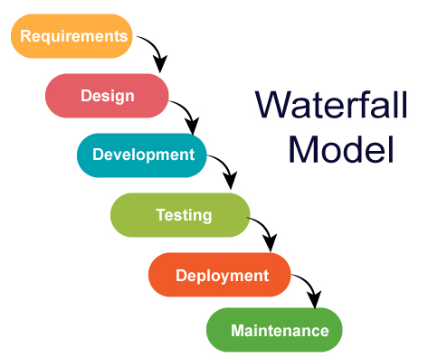

* **Requirement Analysis:**

In this phase, all requirements of the project are analyzed and documented in a specification document and a feasibility analysis is done to check if these requirements are valid. It is essential to consider any limitations and constraints (e.g. time, budget constraints) which can affect the development process. After thorough analysis, a [**Requirements Specification Document**](https://www.smartsheet.com/wise-words-about-writing-technical-requirements-documents) is created.

* **Design:**

In this phase, the system design is prepared which specifies hardware and system requirements, such as data layers, programming languages, network infrastructure, user interface etc. It helps define the overall system architecture.

**Implementation:**

In this phase the source code is written as per requirements. The physical design specifications are turned into a working code. The system is developed in small programs called units, after which these units are integrated. Sometimes, functionality of each unit is tested before integration, which is called [**Unit Testing**](https://www.softwaretestinghelp.com/unit-testing-tools/).

**Testing:**

The code is then handed over to the testing team. Testers check the program for all possible defects, by running test cases either manually or by automation. The client is involved in the testing phase as well, in order to ensure all requirements are met. All Flaws and bugs detected during this phase are fixed to ensure Quality Assurance.

**Deployment:**

In this phase, the software is deployed into a live environment (client’s server) in order to test its performance. Once the [software is deployed](https://technet.microsoft.com/en-us/library/bb496997.aspx), it becomes available to end-users.

**Maintenance:**

After the deployment phase, the next step is to provide support and maintenance for the software, making sure it runs smoothly. If the client and users come across errors/defects/bugs during use, fixing them is the main purpose of this stage.

#### **Spiral model**

* **What is spiral model**

The Spiral Model is a software development methodology that combines elements of both waterfall and iterative development models. The Spiral Model consists of a series of iterative cycles, or spirals, where each spiral represents a phase of the software development process. The main idea behind the model is to gradually refine and enhance the software through a series of iterations, each of which incorporates feedback and lessons learned from the previous iteration.

* **Characteristic**

1. Planning

a. Requirement gathering

b. Identify Company as a client and stakeholder

c. Analyses how to insert data into the system

d. Cost, Schedule, and resource estimation

2. Risk Analysis

a. Design and develop risk mitigation strategies

b. Identify management risk

c. Make Software Requirement Specification document

d. Estimation

3. Development and Testing

a. Prepare the software development document.

b. Prepare the Test Case Specification document.

c. Document the details of testing plan.

d. Get the test analysis approval determination

4. Project Implementation

a. Coding the source code and integration

b. Implement the database

5. Project Testing

a. Performing Functional Testing

I. Conduct the unit testing and record the results

II. Conduct the Integration Testing

b. Performing Non-Functional Testing

I. Conduct the usability testing and record results

II. Conduct the load testing and record results

6. Evaluation

a. Collect all feedback obtained from public customers

* **Spiral model structure**

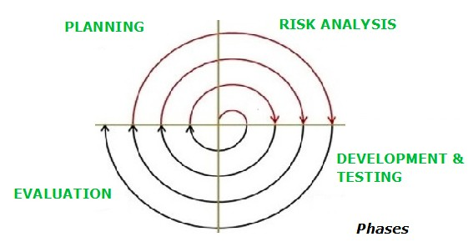

* **When using spiral model**

The Spiral Model is a software development methodology that emphasizes risk management and iterative development. It involves dividing the process into iterations, or spirals, where each spiral represents a phase. It allows for early risk identification and mitigation, as well as incorporating stakeholder feedback through prototyping. The model is flexible and adapts to changing requirements, making it suitable for complex projects. It balances risk management and iterative development to deliver high-quality software.

* **Pros and Cons**

|  |  |
| --- | --- |
| **Pros** | **Cons** |
| 1. Cost estimation becomes easy as the prototype building is done in small fragments 2. Flexibility in changing requirements. In this model, we can easily change requirements at later phases and can be incorporated accurately. Also, additional Functionality can be added at a later date. | 1. There were difficulties in time management. Each spiral requires planning, development, and evaluation, which can extend the project duration and resource requirements. 2. It is more complex than other SDLC models. It involves multiple iterations, risk analysis, and prototyping, which require additional effort in planning and coordination. |

#### **V Model**

* **What is V-Model?**

The V Model is a software development and testing methodology that emphasizes a systematic and structured approach. It is called the V Model because of its V-shaped diagram that illustrates the relationship between the development and testing phases.

In the V Model, the development and testing activities are aligned in a sequential manner, with each phase having a corresponding testing phase. The development phases include requirements gathering, system design, architectural design, module design, coding, and unit testing. The testing phases include unit testing, integration testing, system testing, and acceptance testing.

The key principle of the V Model is that testing is an integral part of each development phase. Testing activities are designed to ensure that the software meets the specified requirements and functions correctly at every level of the development process.

By aligning development and testing activities, the V Model helps to ensure that quality is built into the software from the early stages. Defects and issues can be identified and resolved early in the process, reducing the likelihood of major problems surfacing later.

**Key stages of the V-Model:**

1. Requirements Analysis: Gathering and analysing system requirements.

2. System Design: Creating a high-level design of the system.

3. Subsystem/Module Design: Designing individual subsystems or modules.

4. Implementation: Coding, unit testing, and module integration.

5. Integration and Testing: Integrating modules and conducting various tests.

6. System Testing: Testing the integrated system against defined requirements.

7. Acceptance Testing: Handing over the software to end-users for testing in a real-world environment.

The V-Model emphasizes early and continuous testing throughout the development life cycle. However, it is a traditional waterfall approach and may not be suitable for all projects. Agile methodologies have gained popularity as more flexible alternatives to the V-Model.

* **Characteristic**

The V-Model has several characteristics that distinguish it from other software development life cycle models:

1. **Emphasis on Testing:** The V-Model places significant emphasis on testing activities throughout the development process. Testing is not seen as a separate phase but rather integrated with each development phase, ensuring that verification and validation occur at every step.
2. **Structured and Sequential:** The V-Model follows a structured and sequential approach to software development. Each phase has a corresponding testing phase, and progress moves from left to right in a sequential manner.
3. **Clear Documentation:** The V-Model encourages clear documentation at each stage of development. Requirements, design specifications, and test plans are documented to ensure a clear understanding of the system and facilitate effective testing.
4. **Early Defect Detection:** By conducting testing activities in parallel with development, the V-Model aims to detect defects and issues early in the process. This helps in minimizing the cost and effort required for fixing defects discovered later in the development life cycle.
5. **Traceability:** The V-Model emphasizes traceability between each phase of development and its corresponding testing phase. This ensures that the final system meets the defined requirements and objectives.
6. Rigidity: The V-Model is considered a rigid and inflexible model compared to more agile methodologies. It may not easily accommodate changes or evolving requirements during the development process.
7. **Well-suited for Critical Systems**: The V-Model is often employed in projects where safety-critical or high-reliability systems are developed. Its focus on rigorous testing and verification activities helps in ensuring the quality and reliability of such systems.

It's important to note that while the V-Model has its advantages in certain contexts, it may not be the most suitable approach for all software development projects. Factors such as project size, complexity, and flexibility requirements should be considered when selecting an appropriate development life cycle model.

* **V model Structure**

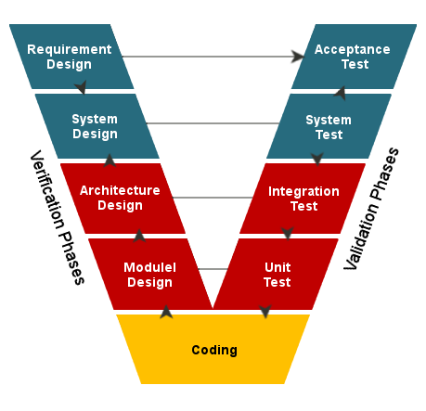

* **When we use V model?**

The V-Model is used in software development projects when the following factors are present:

**1. Clear and Stable Requirements:** The V-Model is suitable when the project requirements are well-defined, understood, and not expected to change significantly. It works best when there is a clear understanding of the project's scope from the beginning.

**2. Emphasis on Verification and Validation:** The V-Model is chosen when there is a strong focus on thorough verification and validation activities. It ensures that testing and quality assurance activities are integrated throughout the development process, allowing for early defect detection and ensuring compliance with requirements.

**3. Safety-Critical Systems:** The V-Model is often utilized in projects involving safety-critical systems. These are systems where reliability, security, and adherence to regulations are of utmost importance. The V-Model's rigorous testing and verification activities help ensure the quality and reliability of such systems.

**4. Small to Medium-Sized Projects:** The V-Model is well-suited for projects of small to medium size and well-defined scope. Its structured and sequential nature facilitates easier management and control of the project. However, for larger projects, the V-Model's rigidity and lack of flexibility may pose challenges in accommodating changes.

**5. Documentation and Traceability**: The V-Model promotes the practice of clear documentation at each stage of the development process. This ensures that requirements, design specifications, and test plans are properly documented, enabling traceability between development phases and testing activities.

**6. Availability of Testing Resources:** The V-Model requires skilled testers and sufficient resources for comprehensive testing. As testing is an integral part of each development phase, having the necessary expertise and resources is essential for successful implementation of the V-Model.

While the V-Model has its advantages, it is important to note that it is a traditional waterfall approach and may not be suitable for projects with evolving requirements or a need for frequent customer collaboration. Agile methodologies provide more flexibility in those cases. The choice of development model should consider the project's specific characteristics, stakeholder needs, and desired level of adaptability.

|  |  |
| --- | --- |
| **Pros** | **Cons** |
| Clear structure that is easy to understand | Limited flexibility in accommodating changes or evolving requirements |
| Early and continuous testing, leading to improved software quality | Inefficient resource utilization, potentially causing longer feedback loops |
| Strong emphasis on verification and validation | Late user feedback, limiting early user engagement |
| Documentation and traceability for better project management | Limited opportunities for stakeholder collaboration |
| Suitable for safety-critical systems with rigorous testing requirements | Rigid structure, making it challenging to adapt to changing project needs |

* **Pros and Cons**

#### **Agile model**

* **What is agile model?**

The agile software development life cycle (SDLC) model combines iterative and incremental process models with a focus on process adaptability and customer satisfaction through quick delivery of functional software. The product is divided into smaller incremental builds using agile methods. Iterations of these builds are supplied. Usually, an iteration lasts between one and three weeks. Cross-functional teams work simultaneously on several different topics during each iteration, including:

* Planning
* Requirements Analysis
* Design
* Coding
* Unit Testing and
* Acceptance Testing.

According to the agile approach, each project should be managed differently, and the existing procedures should be adjusted as necessary to better meet the project's demands. To deliver specific features for a release, tasks are separated into time boxes (short time spans) in the agile methodology.

Working software builds are delivered after each iteration using an iterative technique. In terms of features, each build is incremental; the final build contains all the features requested by the client.

* **Characteristic**

**Iterative and Incremental Development:** Agile focuses on breaking the project into smaller iterations or increments, with each iteration delivering a working piece of software. This allows for continuous feedback, adaptation, and improvement throughout the development process.

**Customer Collaboration**: Agile prioritizes active involvement and collaboration with the customer or end-users throughout the development lifecycle. Their feedback and requirements guide the development process, ensuring that the software meets their needs and expectations.

**Adaptive and Flexible:** Agile embraces change and welcomes evolving requirements. It allows for adjustments and refinements to be made at any stage of development, enabling the software to better align with changing business needs or customer preferences.

**Cross-functional Teams:** Agile encourages the formation of self-organizing, cross-functional teams that possess all the necessary skills to design, develop, test, and deliver the software. These teams promote effective collaboration, communication, and shared accountability.

**Continuous Delivery and Testing:** Agile emphasizes delivering working software in short iterations. Each increment undergoes continuous testing, enabling early detection and resolution of defects. This helps ensure that the software is of high quality and meets the desired functionality.

**Transparency and Communication:** Agile promotes open and transparent communication within the development team and with stakeholders. Regular meetings, such as daily stand-ups or sprint reviews, facilitate information sharing, progress updates, and issue resolution.

**Emphasis on Value:** Agile aims to deliver value to the customer quickly and frequently. It focuses on prioritizing features or functionality that provides the most significant value or return on investment.

**Empirical and Data-driven Approach:** Agile relies on empirical evidence and real-time data to inform decision-making and process improvement. Feedback and metrics are used to identify areas for optimization and enhance project outcomes.

It's important to note that while these characteristics generally apply to Agile methodologies, specific implementations may vary. Agile frameworks such as Scrum, Kanban, and Extreme Programming (XP) offer their own practices and guidelines that align with these characteristics.

* 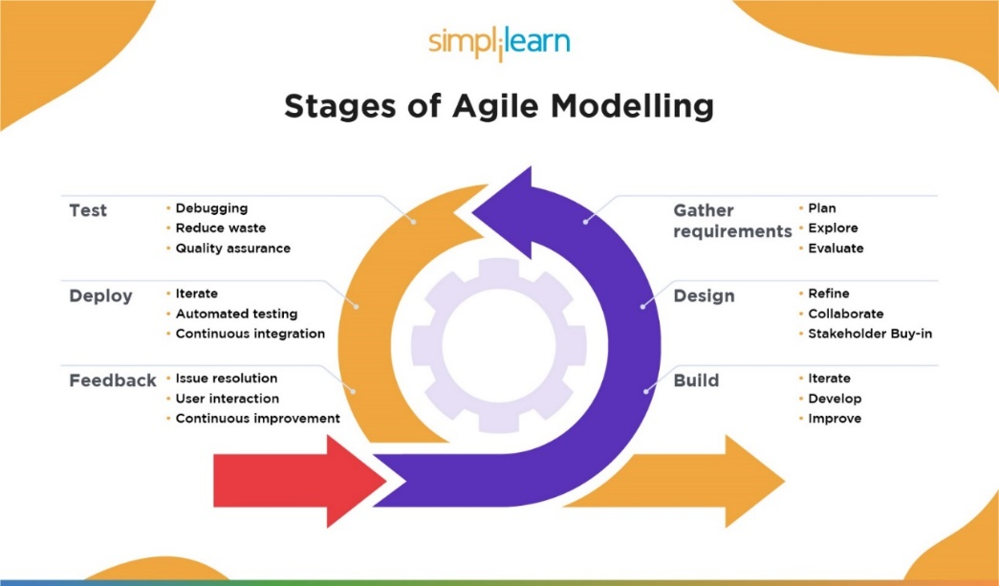**Agile model structure**
* **When we use agile model?**

Agile is a project management approach that is better suited for continuing projects and projects where some details aren't known from the beginning because of its core principles, which include adaptability, iteration, continuous delivery, and short time frames, among others. Therefore, an Agile strategy is a smart choice for a project that lacks precise limitations, deadlines, or resources.

For instance, creating and launching a new product may force a team to overcome a number of unexpected difficulties. A project may already have the methodology to test products as frequently as necessary, iterate quickly, and communicate changes to stakeholders if it uses an Agile approach.

**Pros and Cons**

|  |  |
| --- | --- |
| **Pros** | **cons** |
| 1. Ability to manage changing priorities | 1. Organizations can resist change in adoption |
| 1. Increased project visibility | 1. Teams may use inconsistent practices |
| 1. Improved business/IT alignment | 1. Needs support of leadership and management |
| 1. Delivery speed/time to market | 1. Organizational culture can be at odds with agile values |
| 1. Project risk reduction |  |
| 1. Project predictability |  |

* 1. **Chosen SDLC Method- Agile Method**

We have chosen Agile method due to its flexibility. Creating and launching a new product may force a team to overcome a number of unexpected difficulties. A project may already have the methodology to test products as frequently as necessary, iterate quickly, and communicate changes to stakeholders if it uses an Agile approach. Since this project is complex, and we are mere beginners of developing, we may face issues and errors that will require changes after a phase is completed. This method gives us flexibility to overcome it.

**Selected Techlogies :**

• Front-End Tech: ReactJS

• Back-end Tech.: Spring boot.

• Database: MySQL

• IDEs: Spring Tool Suite, Visual Studio Code

**1. Front-End Technology**

a. React JS



React JS is a popular JavaScript library developed and maintained by Facebook. It is an open-source tool used to build efficient and scalable web applications. React JS is specifically designed for front-end web development and is known for its speed, flexibility, and unique functionality.

**2. Back-End Technology**

a. Spring Boot

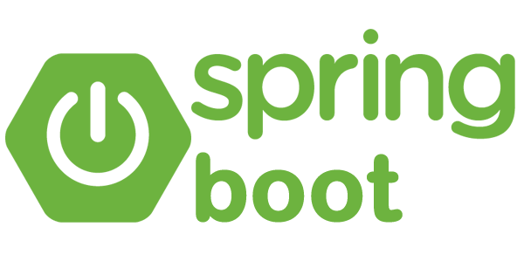

Spring Boot is a java-based open-source framework that allows for easy development of standalone and production-ready spring applications. It offers various features such as auto-configuration, standalone deployment, and opinionated design, making it a versatile and user-friendly tool for building robust applications.

**3. Database**

a. MySQL Workbench

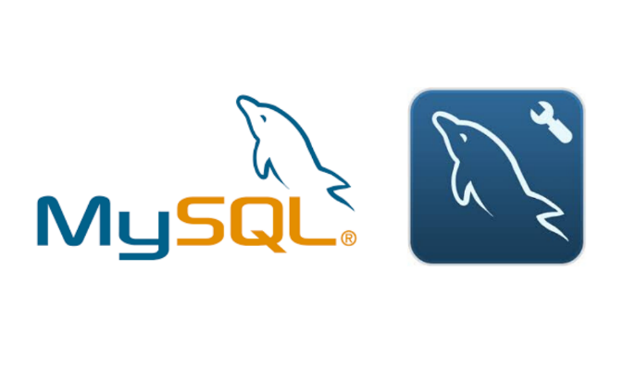

MySQL is a popular Relational Database Management System (RDBMS) developed by Oracle. It is based on a structured query language and is used for organizing and managing structured data. A database is a structured collection of information, ranging from simple shopping lists to complex corporate data repositories. In the case of a relational database, data is stored in tables with rows and columns, and relationships between data elements follow a strict logical structure. An RDBMS is a software toolset used to efficiently handle, manage, and query such a database.

**4. IDEs**

a. Spring Tool Suite

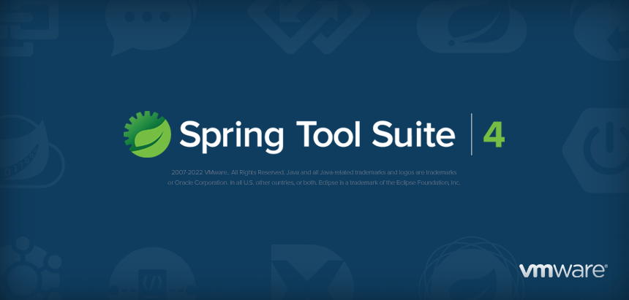

Spring Tool Suite (STS) is a Java Integrated Development Environment (IDE) specifically designed for developing enterprise applications based on the Spring framework. It provides a user-friendly and efficient development experience and is built on top of the Eclipse IDE. STS is available as a free and open-source tool, powered by VMware. The latest version, Spring Tools 4, represents the next generation of tools for Spring development within a preferred coding environment.

b. Visual Studio Code

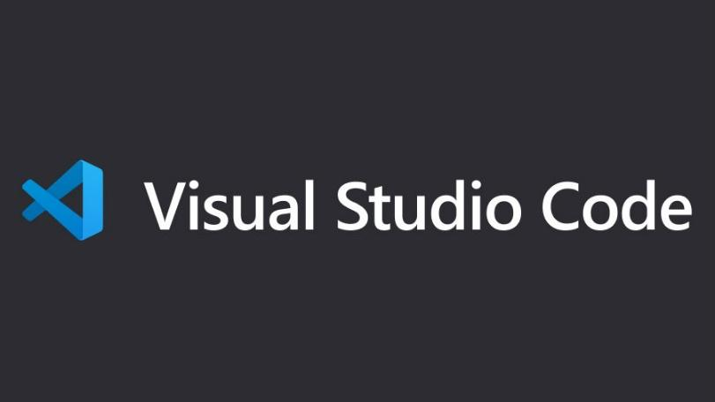

Visual Studio Code is a code editor that offers various development operations such as debugging, task execution, and version control. It aims to provide developers with the essential tools for a quick code-build-debug cycle while leaving more complex workflows to more comprehensive Integrated Development Environments (IDEs) like Visual Studio IDE. It offers a streamlined and efficient coding experience for developers.

**5. Tools: Figma, draw.io, Google document, ERDplus**

**System requirements**

* Man power: 6
* Operating System

• Windows 7 or above

• Android 7 or above

• Mac 9 or above

• iOS 12 or above

* Hardware Requirements

• Intel Xeon 6 TH Gen or Newer CPU

• RAM - 16 GB

• ROM - 1 TB (OS)

• ROM – 16 TB (Data)

• Monitor

• Mouse and Keyboard

* Software Requirements

• Programming Language – Java 11

• Database – MySQL

• Web Server - Tomcat

**Task 4: Project Team**

**4.1. Project member information**

|  |  |  |  |
| --- | --- | --- | --- |
| **Partner** | **Learner ID** | **Full Name** | **Group ID** |
| LCBS | BDSE-0922-136 | Nabila Afsana | G09 |
| FFC | BDSE-0922-103 | Mohamed Haleemdeen Hafsa | G09 |
| JISC | BDSE-0922-067 | Hewa Kondara Gamage Tharushika Nethmi Nilupulie | G09 |
| JISC | BDSE-0922-091 | Warnakulasuriya Manusha Devinda Stallone Thamel | G09 |
| JISC | LIS001207 | Wellarana Witharanage Harsha Tharuka Sandaruwan | G09 |
| FFC | BDSE-0922-106 | Deegala Gonapola Gedara Sajitha Chanaka Pushpakumara | G09 |

**4.2. Team member’s roles and responsibilities**

|  |  |  |
| --- | --- | --- |
|  | **Tasks** | **Name** |
| MO1 | 1. Partners and Volunteers registration with their details 2. Member and Caregivers registration with their requirements | * + Nabila Afsana   + Deegala Gonapola Gedara Sajitha |
| M02 | 1. Fund raising through donors/supporters | * + Wellarana Witharanage Harsha   + Mohamed Haleemdeen Hafsa |
| M03 | 1. Menu Planning and Preparation 2. Meal Delivery Management of partners and riders | * + Warnakulasuriya Manusha Devinda   + Hewa Kondara Gamage |
| M04 | 1. Admin access for managing all backend works  |  | | --- | | * Can set menu | | * Can see and edit donors list | | * Can see and edit members list | | * Can see and edit partners list | | * Can see and edit delivery man’s list | | * Can see and edit order request and order confirmation. | | * + Mohamed Haleemdeen Hafsa   + Hewa Kondara Gamage   + Warnakulasuriya Manusha Devinda   + Deegala Gonapola Gedara Sajitha   + Nabila Afsana |

**4.3. Task Detail: Module Wise**

**M01: 1. Partners registration with their details**

**Frontend:**

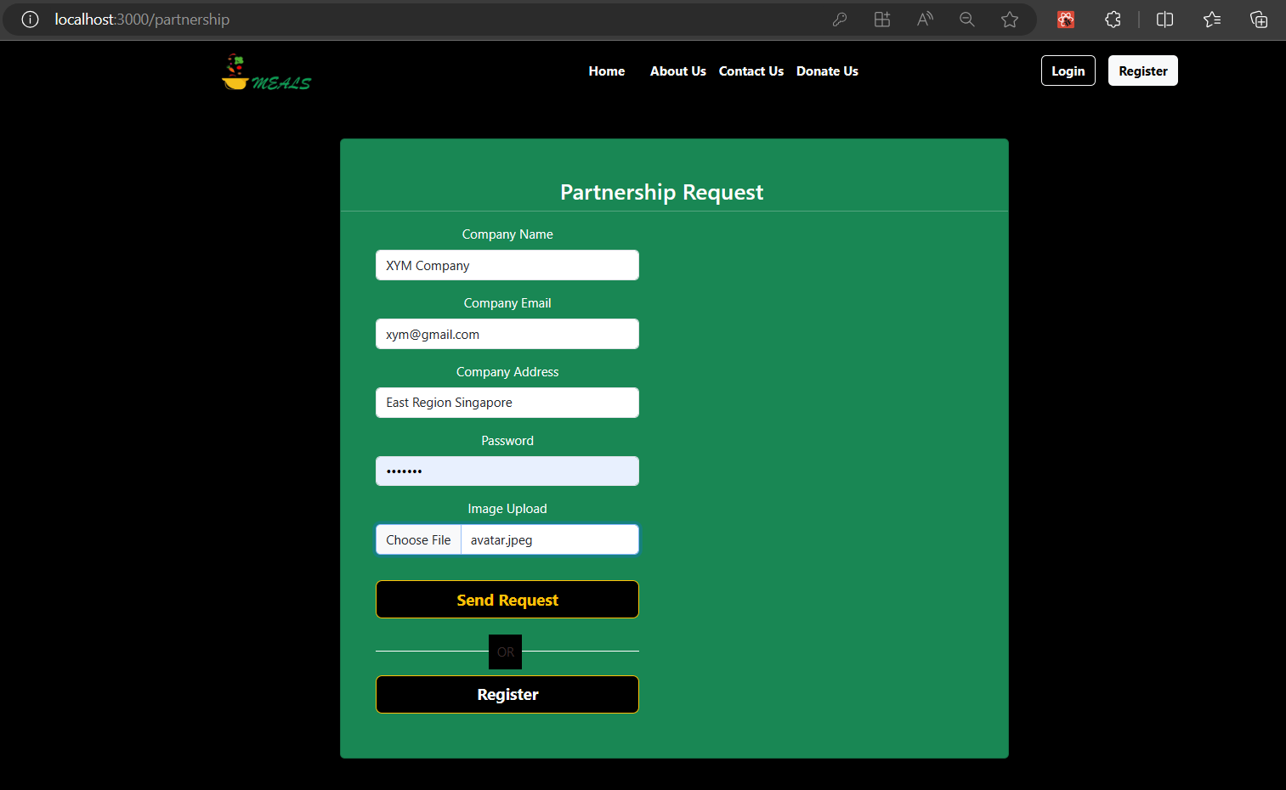

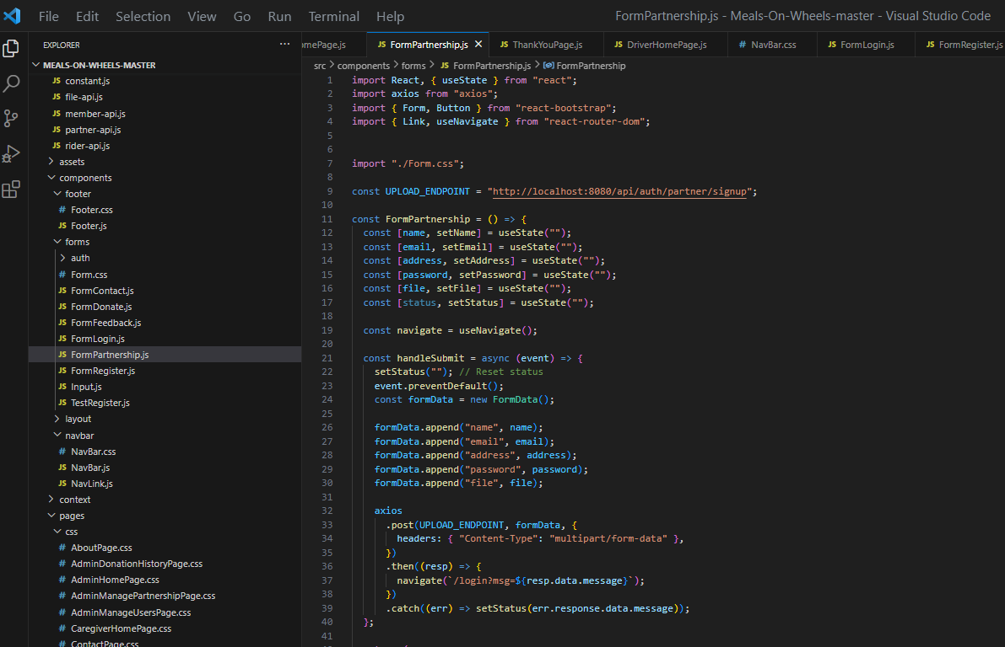

**Database:**

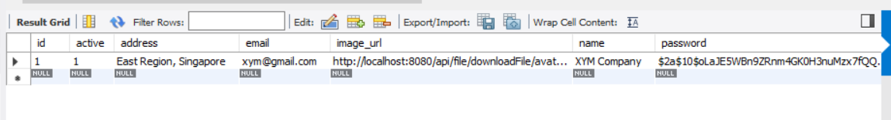

**Backend:**

**Model**

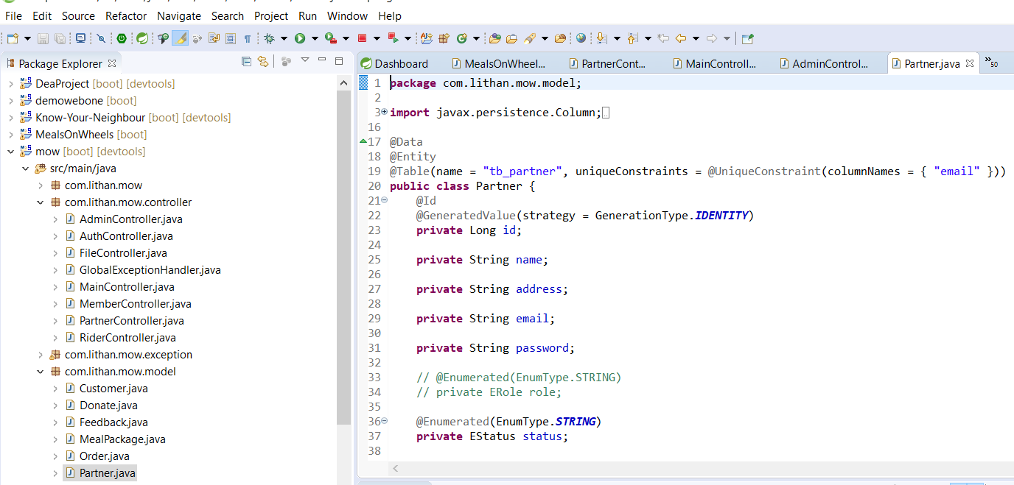

**Controller:**

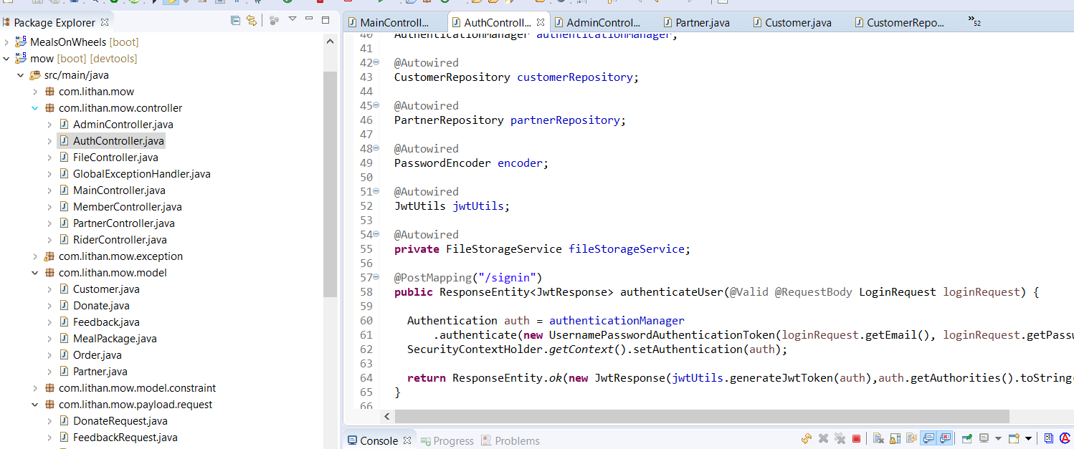

**Repository:**

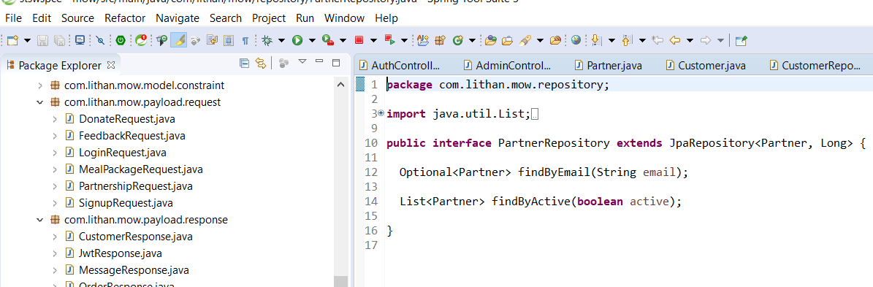

**Partner HomePage:**

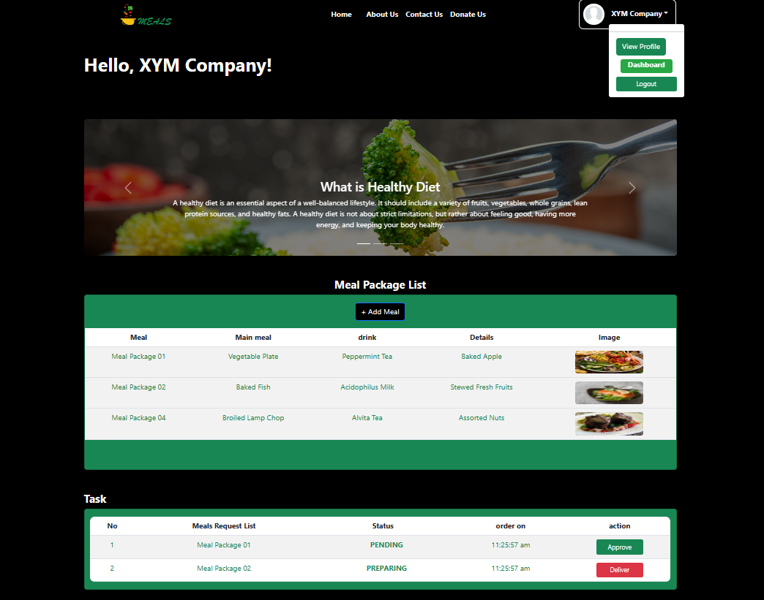

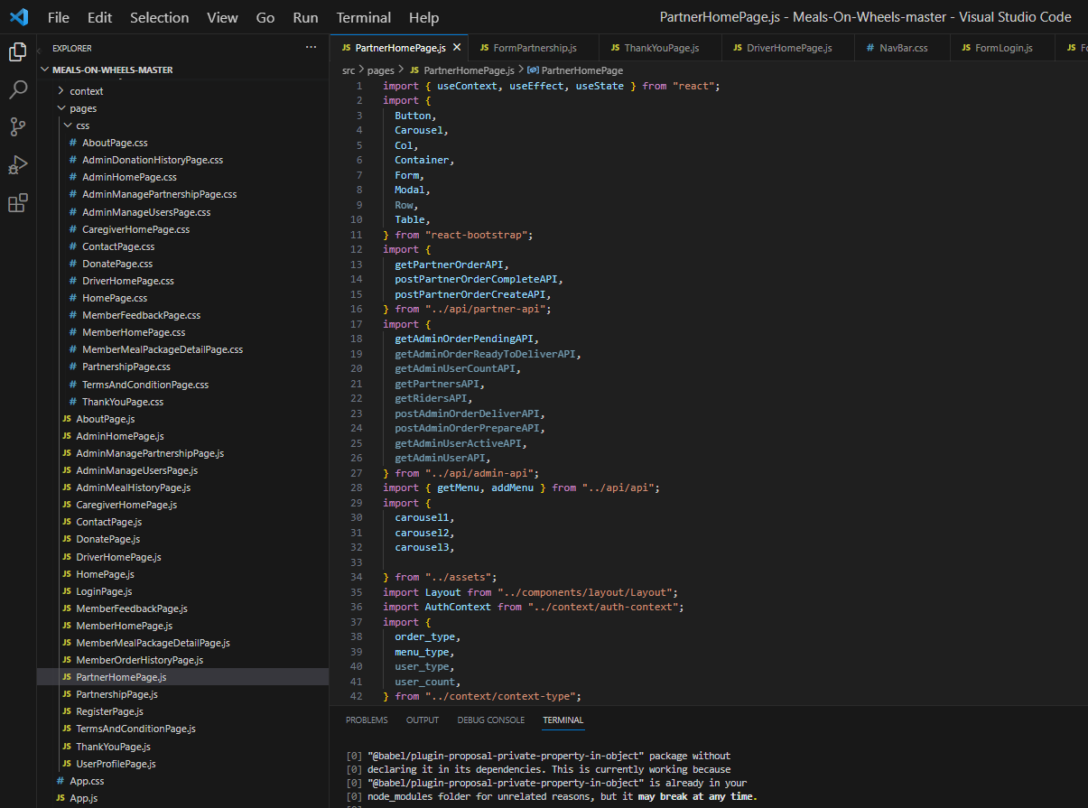

**Partner Dashboard:**

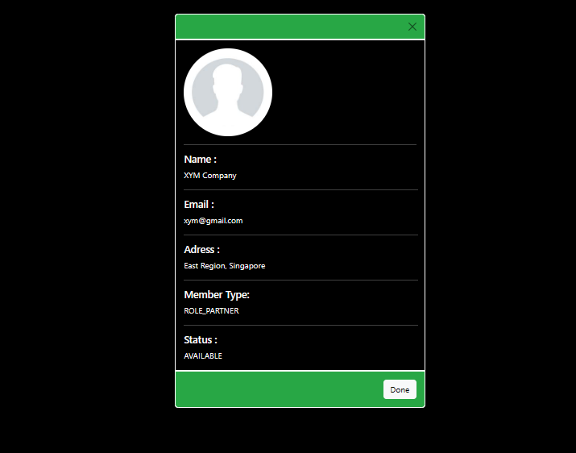

**M01: 2. Member and Caregivers registration with their requirements**

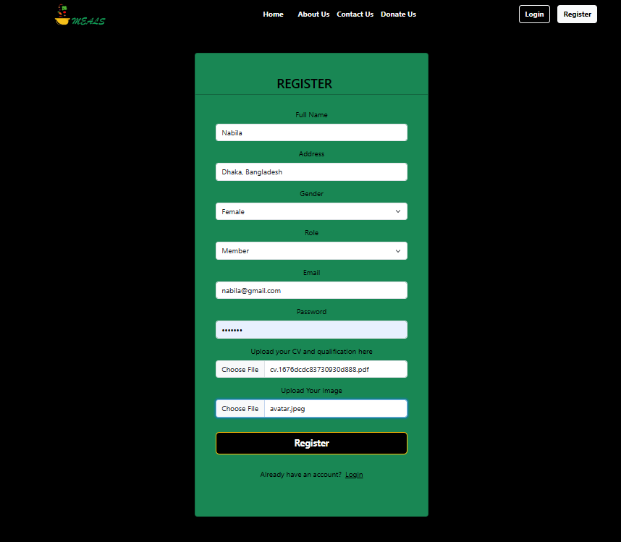

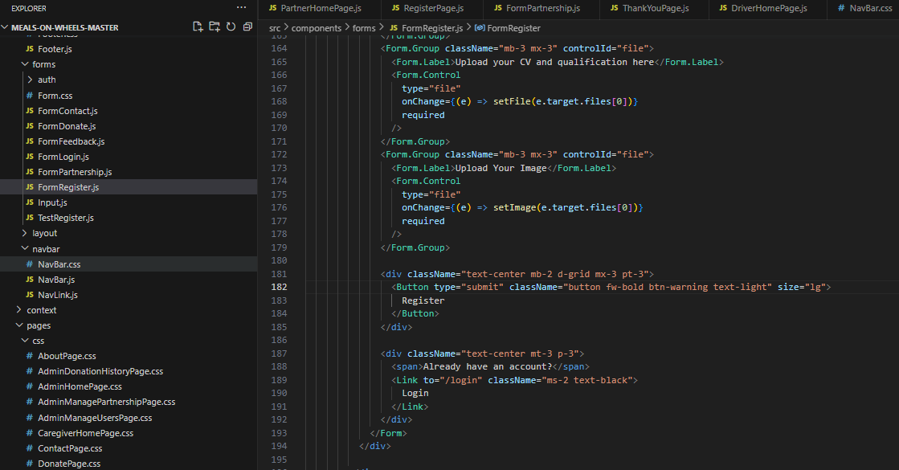

**Database:**



**Backend:**

**Model**

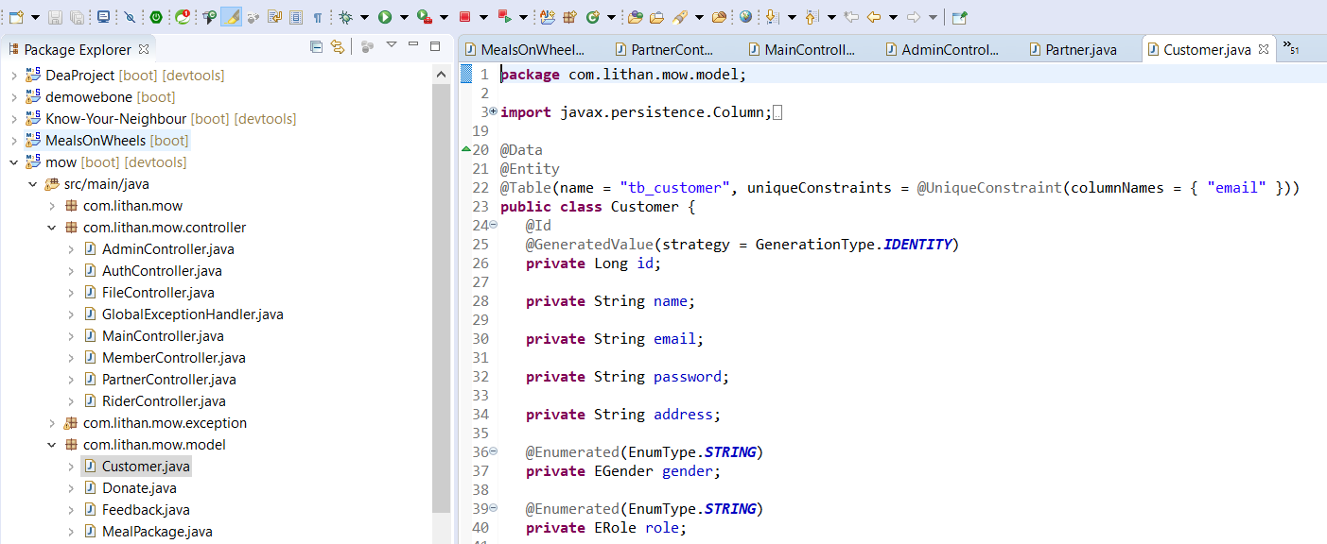

**Auth Controller:**

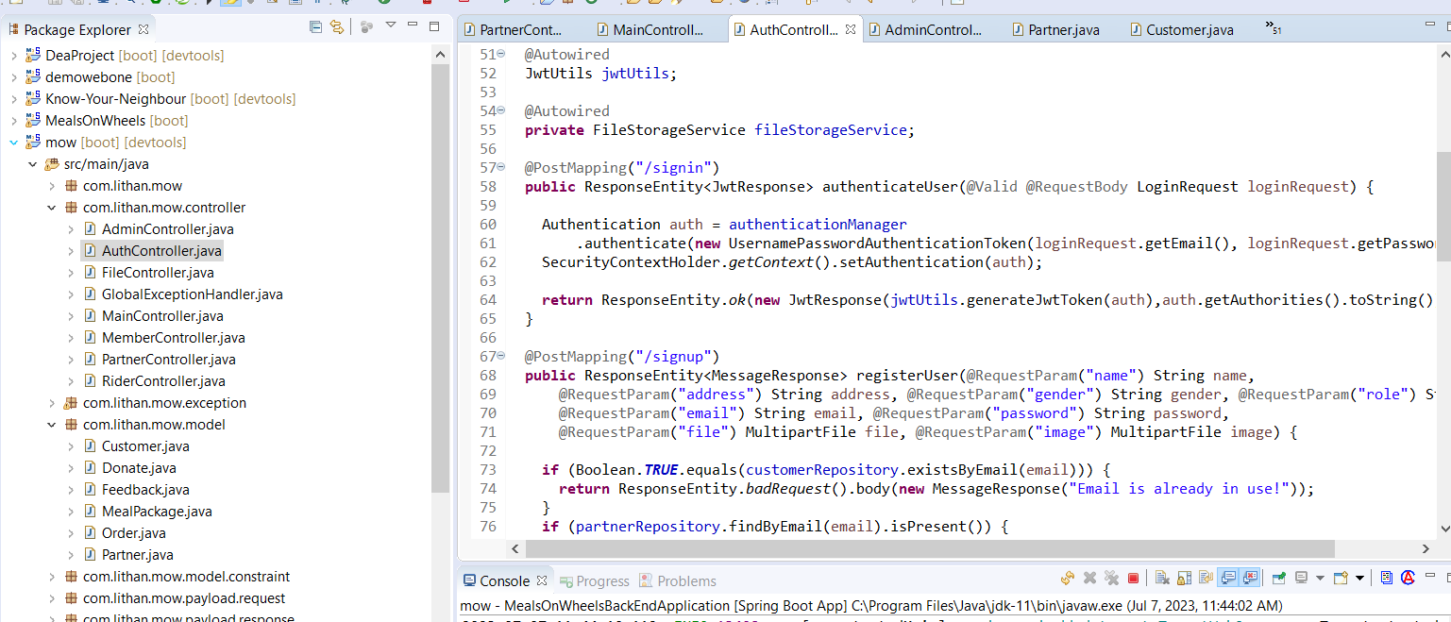

**Role Repository:**

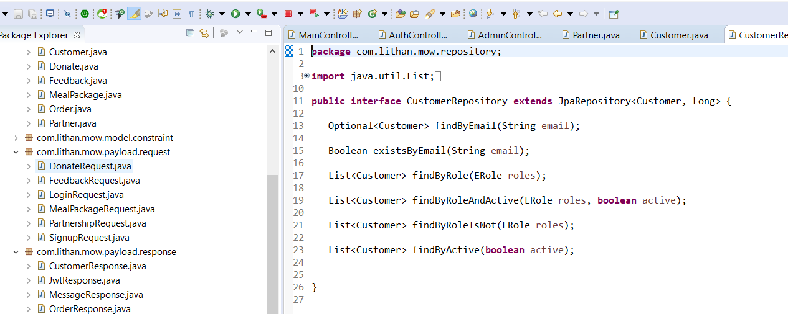

**M02: 1. 1. Fund raising through donors/supporters**

**Frontend:**

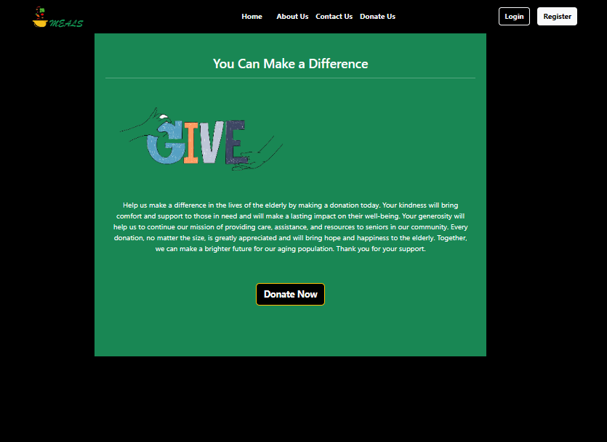

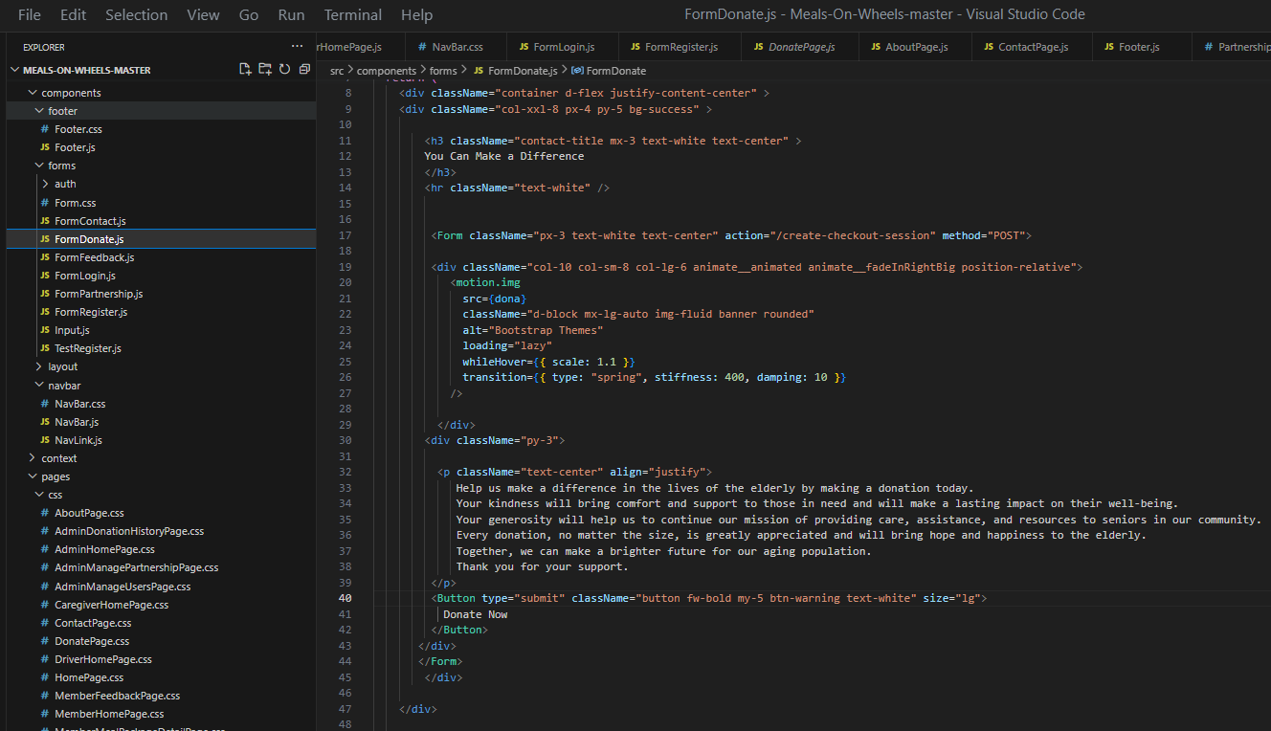

**Fill Up the information and pay**

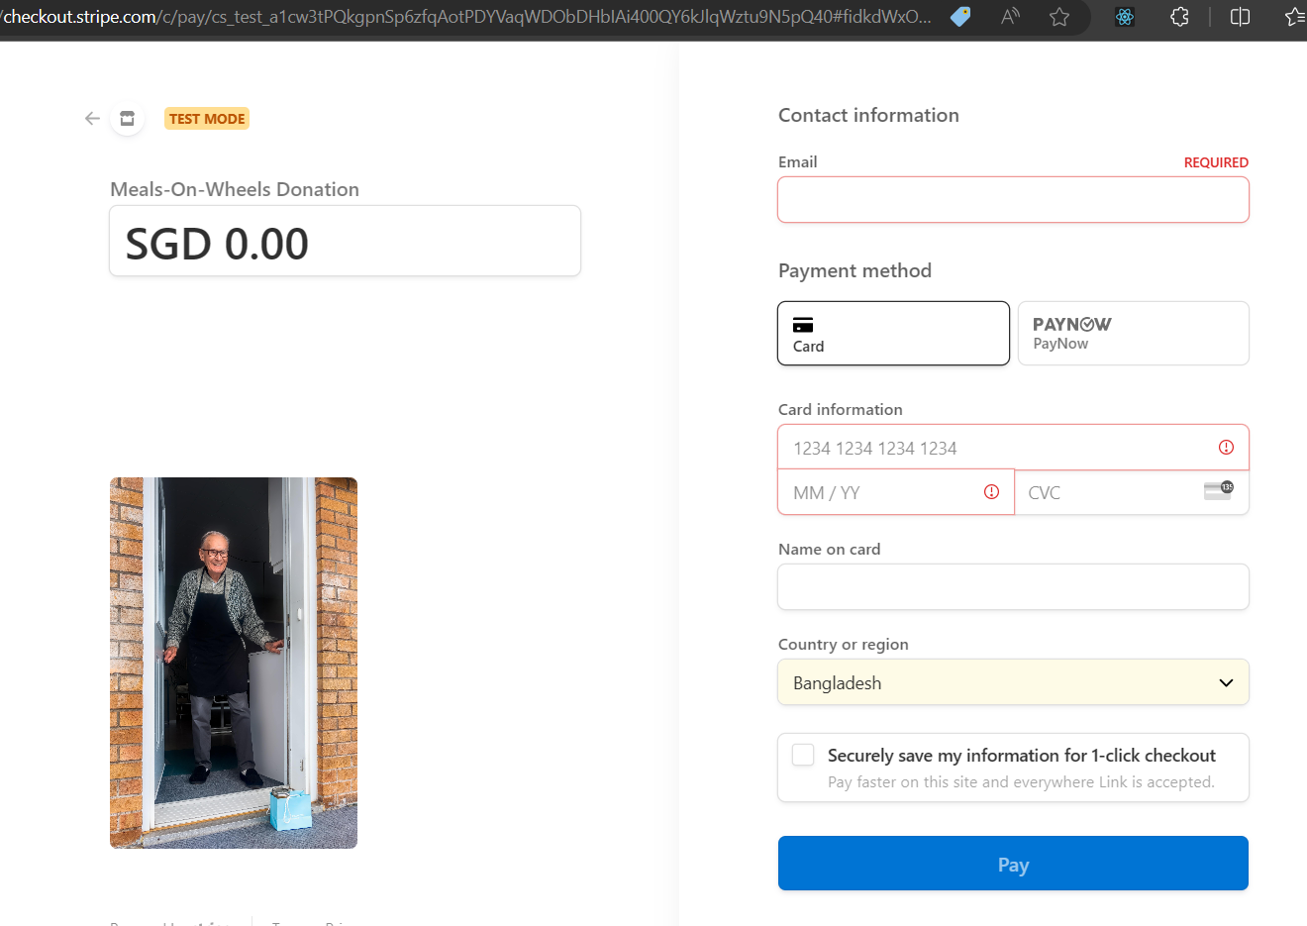

**Backend:**

**Model:**

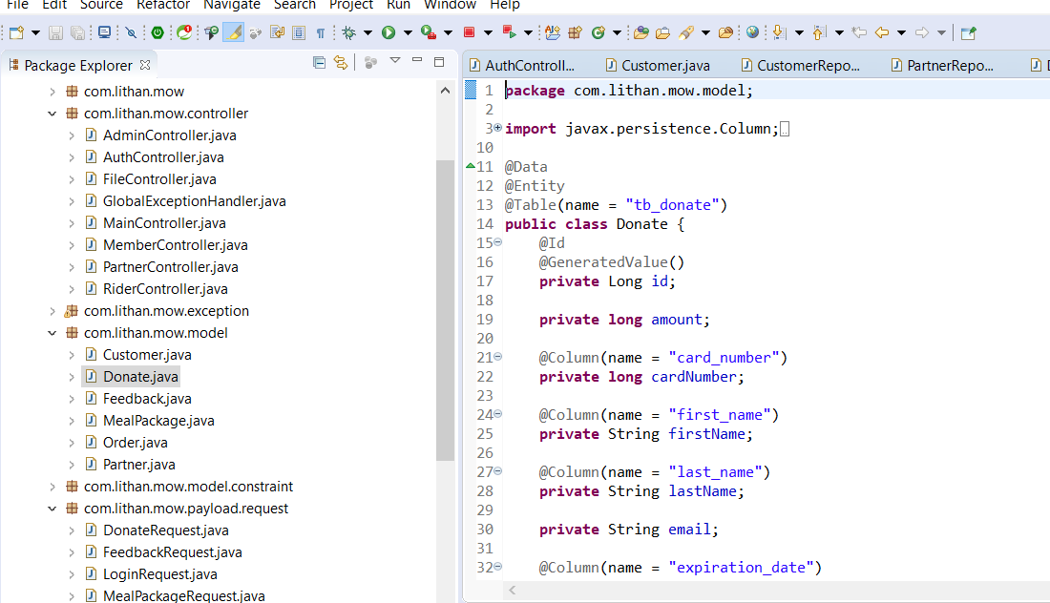

**Repository:**

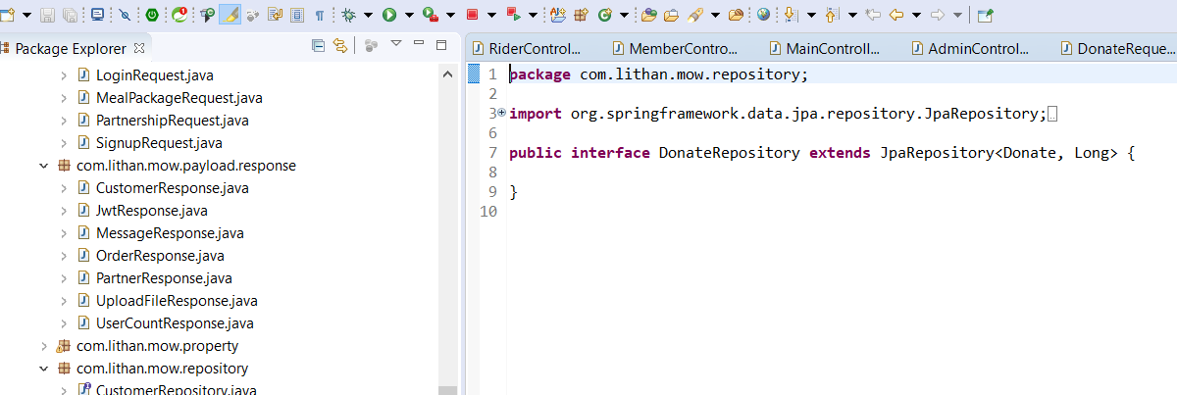

**Request:**

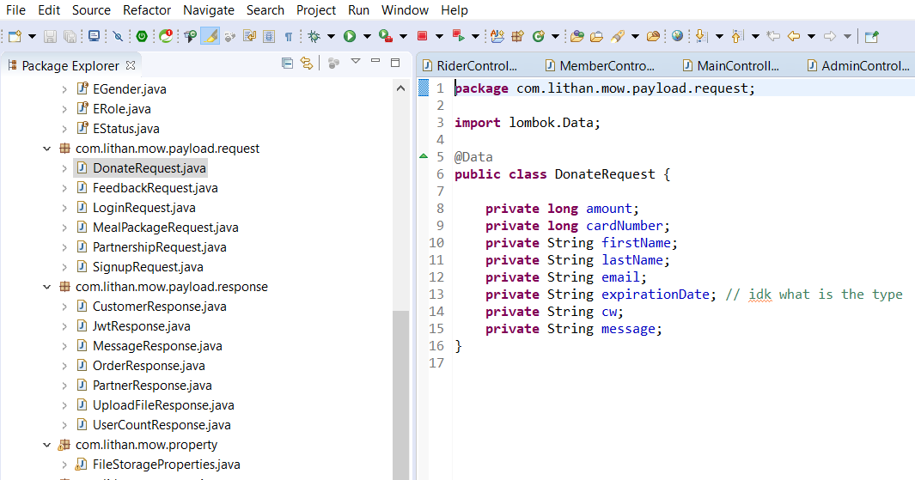

**M03: 1: 1. Menu Planning and Preparation**

**From Partner Side:** After successful login**,** on the partner dashboard, partner can see today’s Meal package list and Order Status.

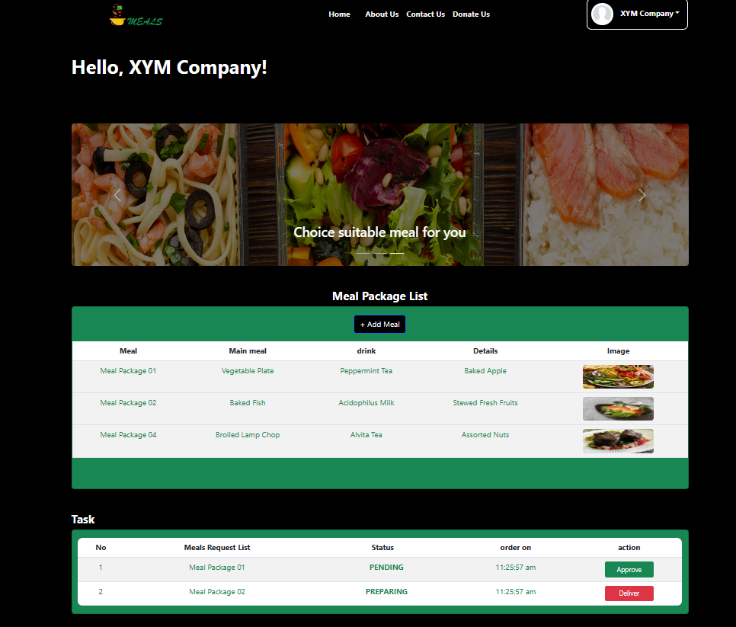

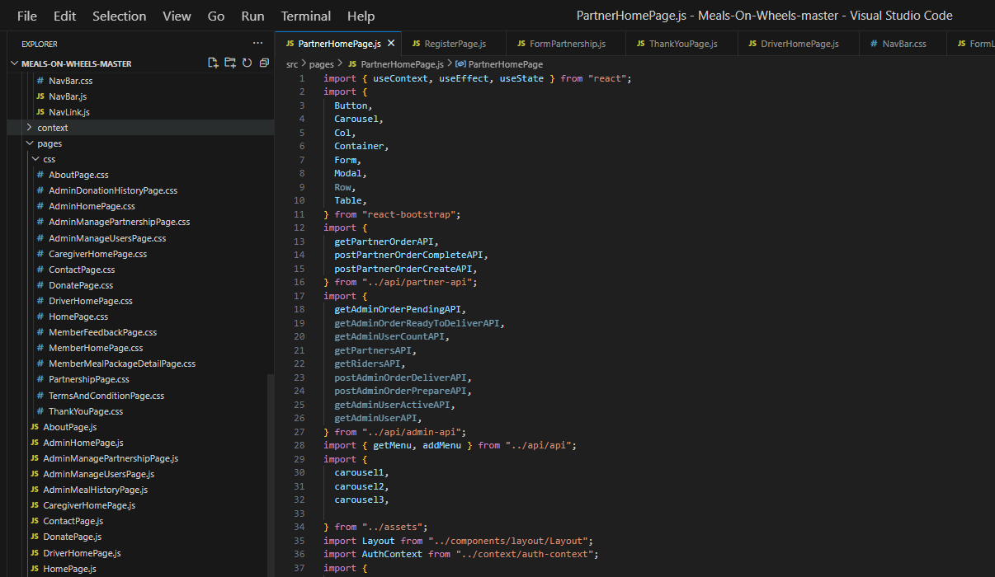

**Backend:**

**Controller**

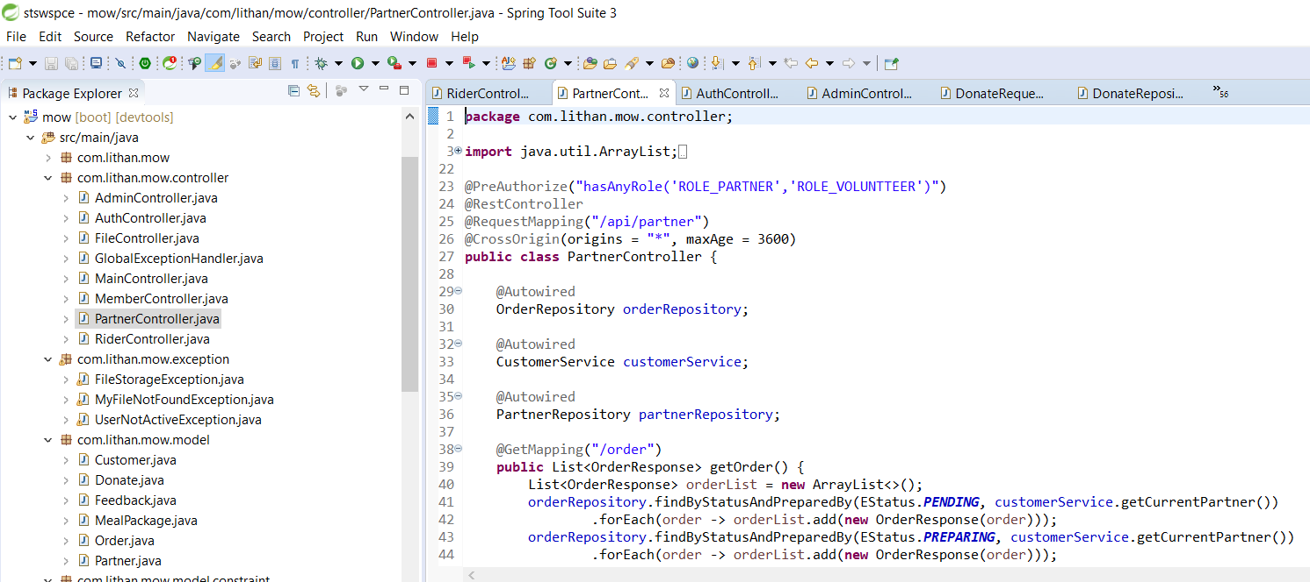

**Menu List From Member Side:**

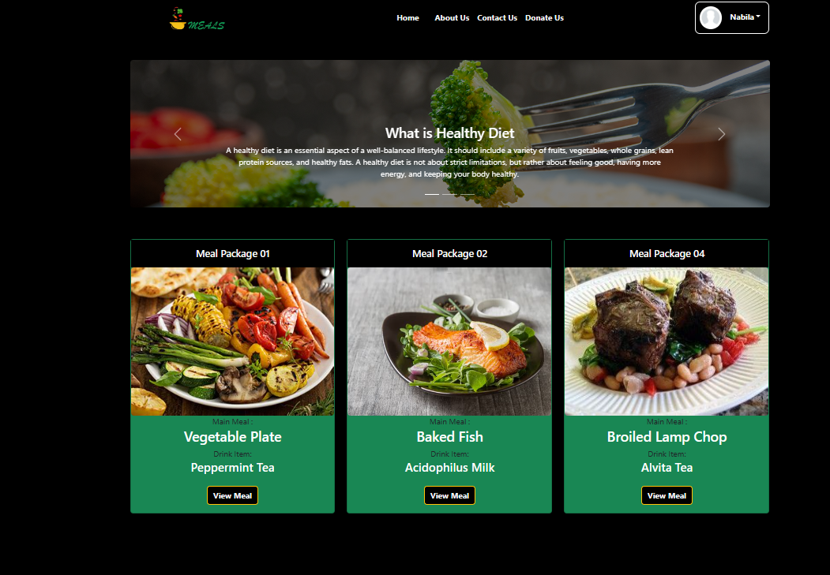

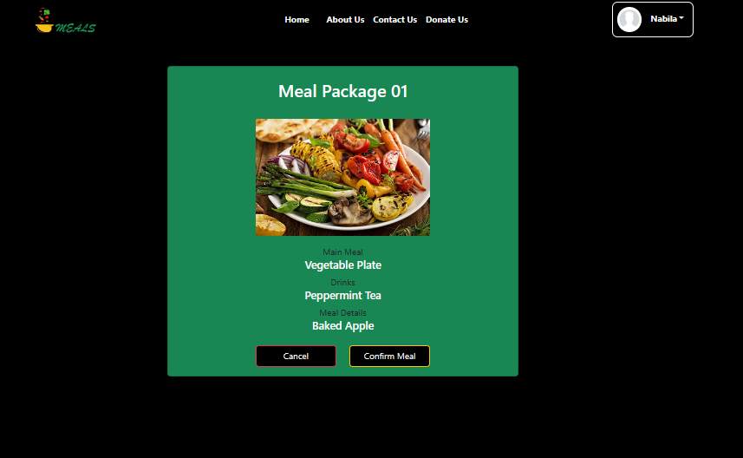

**Backend**

**Controller**

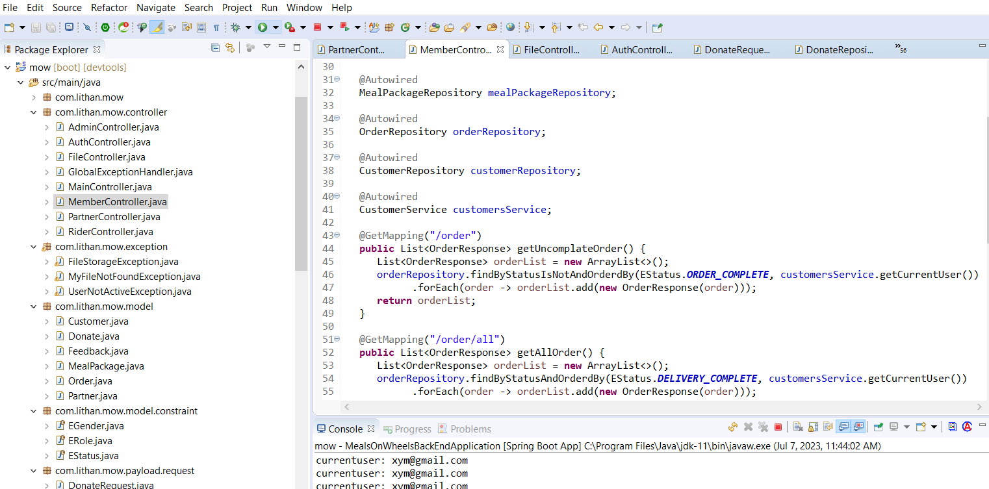

**Model:**

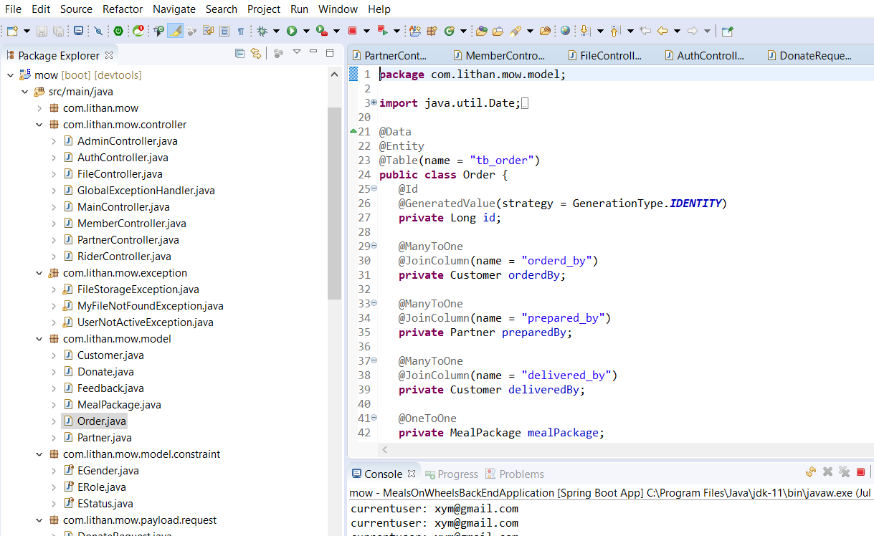

**M03: 2. Meal Delivery Management of partners and riders**

After confirming delivery, partner can update the delivery status in the below section.



**Controller**

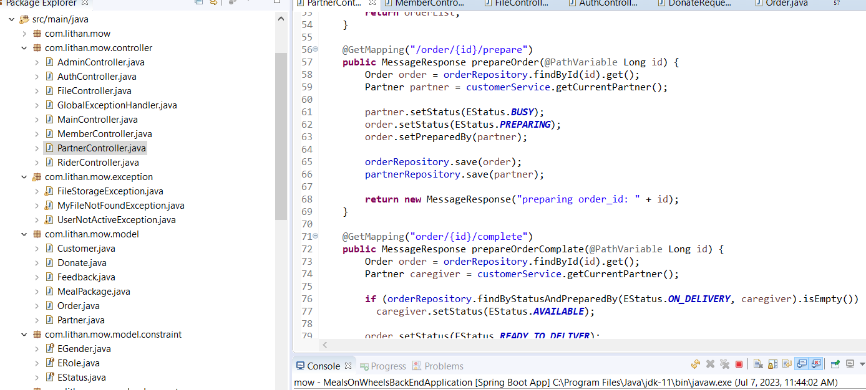

**Rider Delivery Management:** Rider can update Rider availability status and also update delivery status on the marked sections.

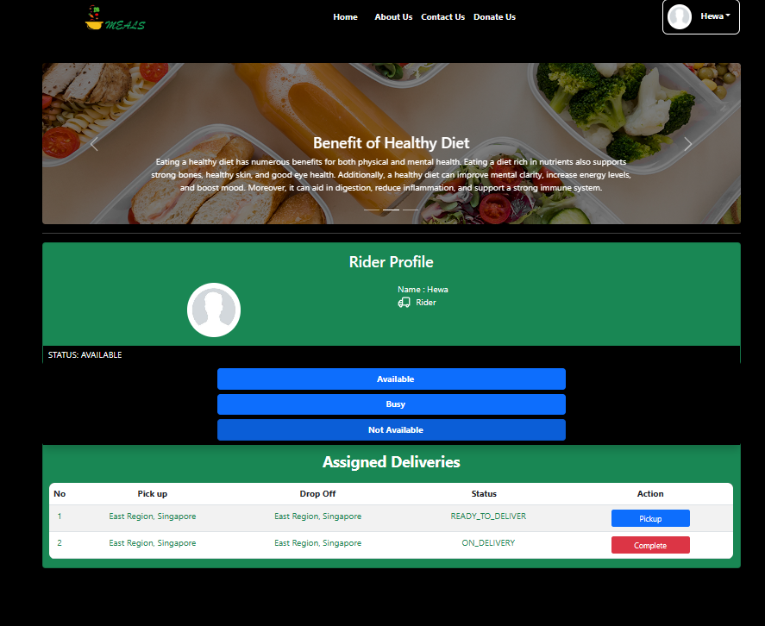

**M04. 1. Admin access for managing all backend works**

**Admin can assign partner task:**

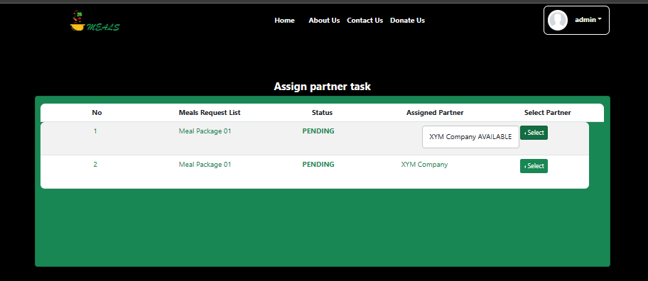

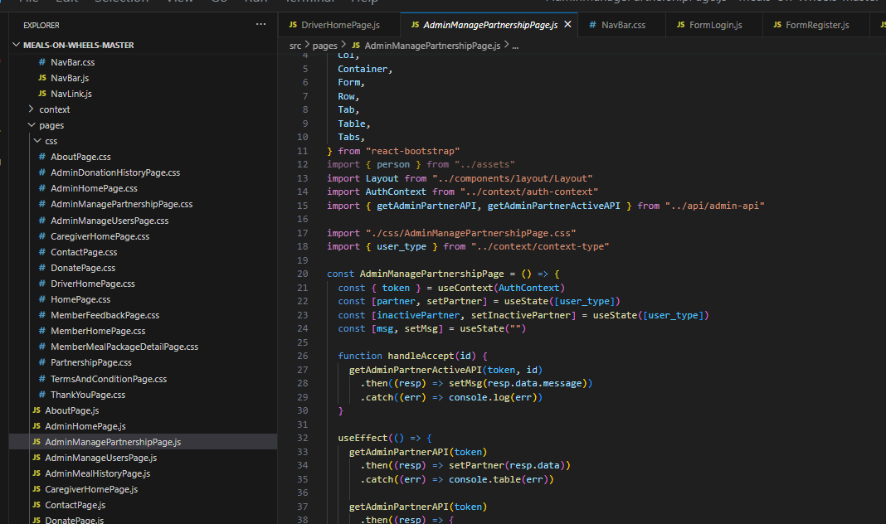

**Backend:**

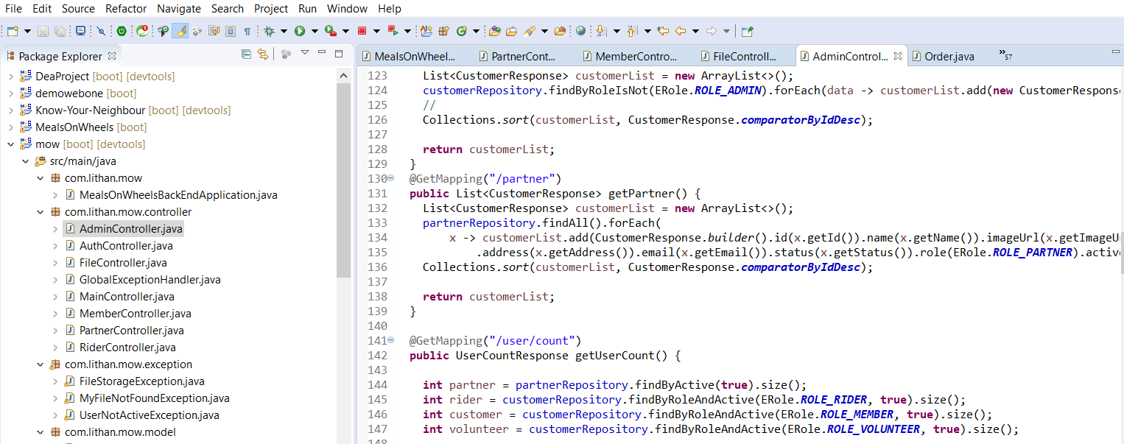

**Admin can set menu:**

By clicking on Add Meal button admin will get the set menu form.

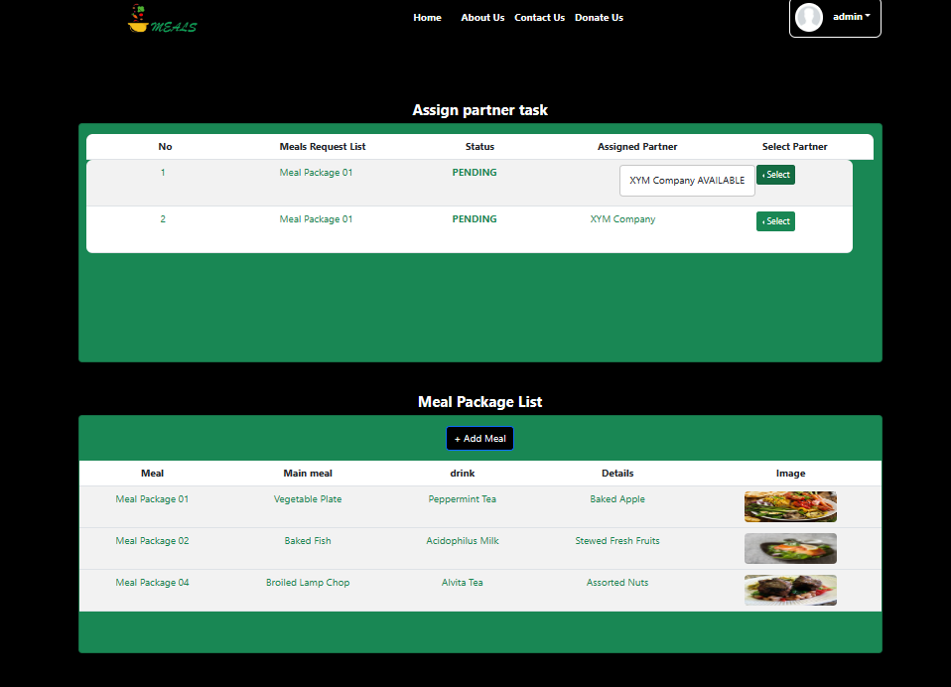

**Admin will insert all the menu list and by clicking on submit menu will be set.**

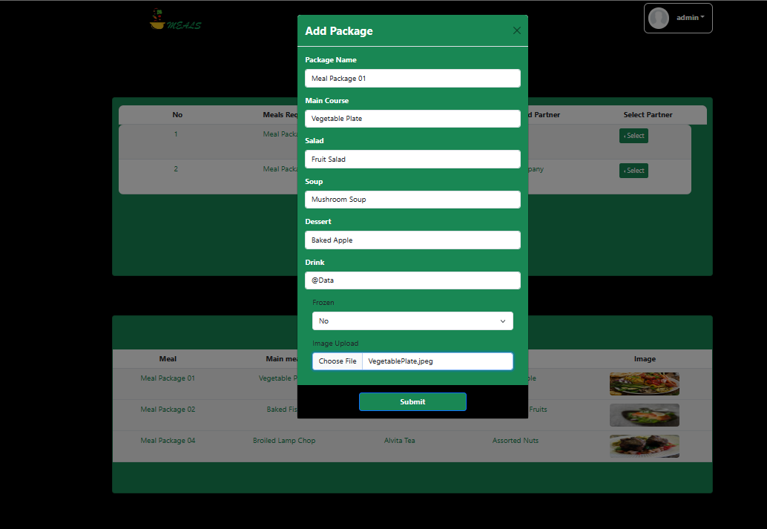

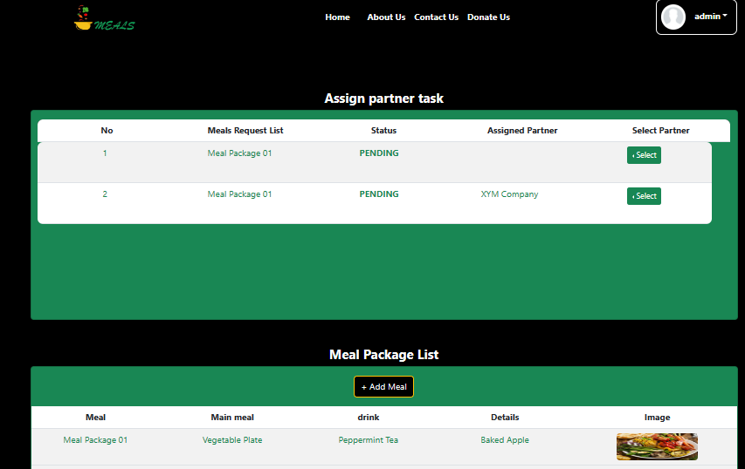

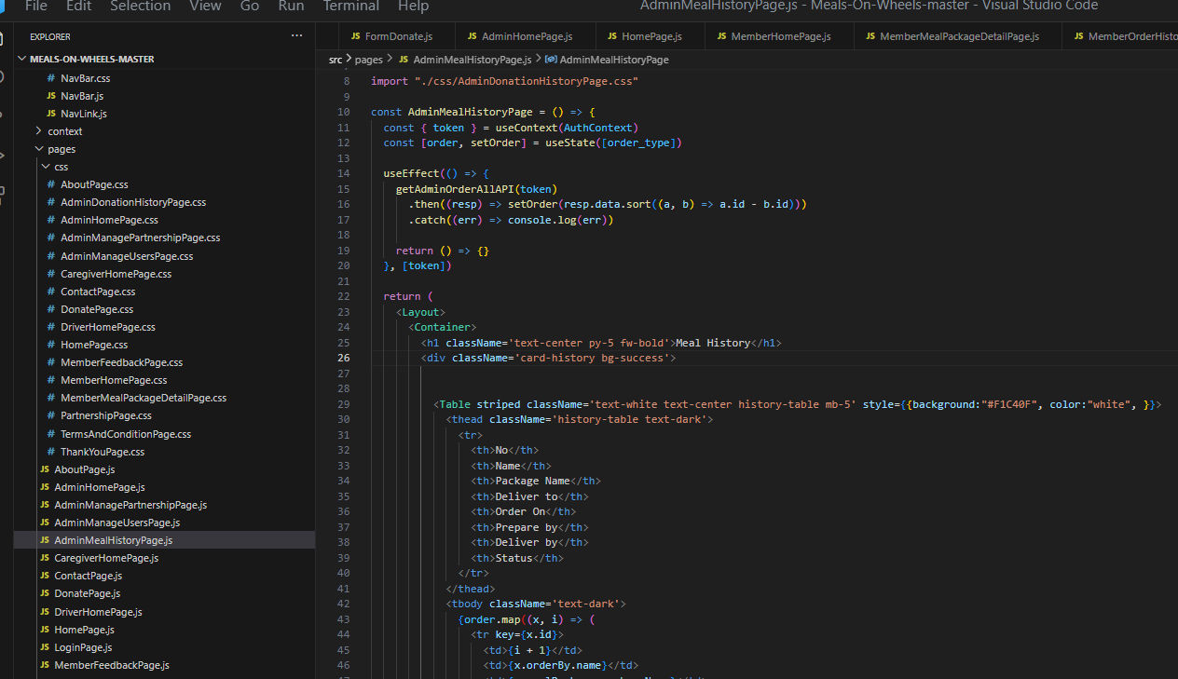

**Backend:**

**Model:**

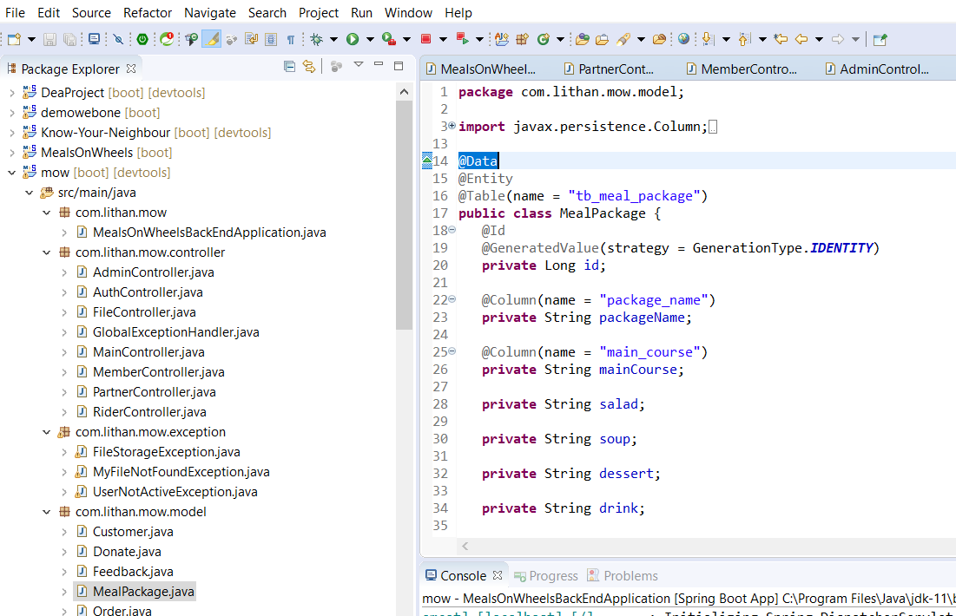

**Controller:**

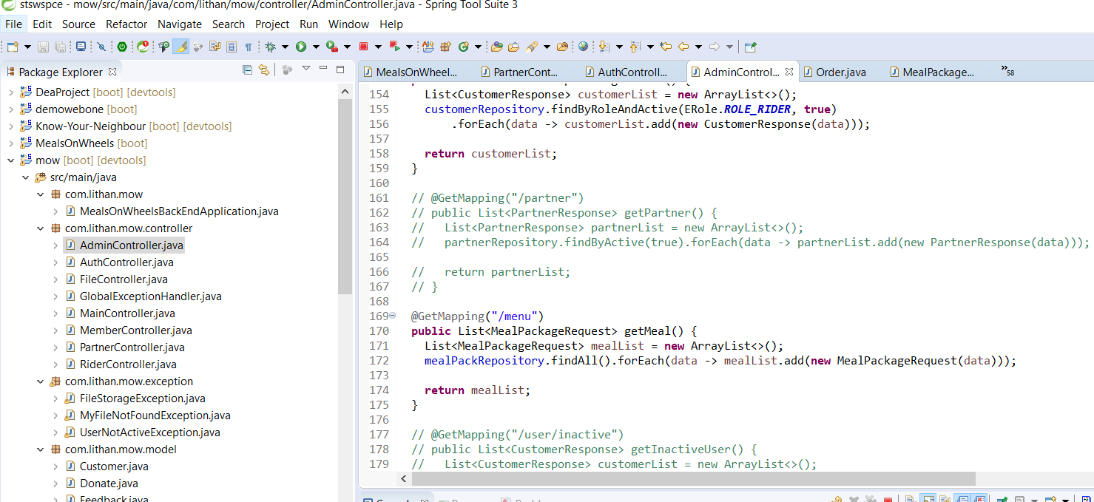

**Repository:**

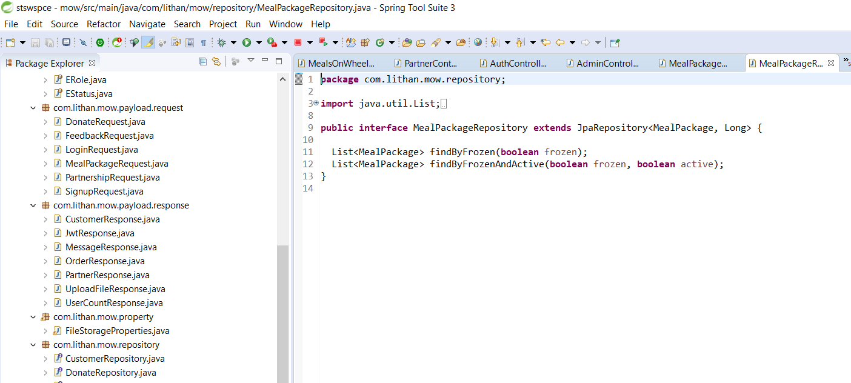

**Admin can manage member, rider, volunteer:**

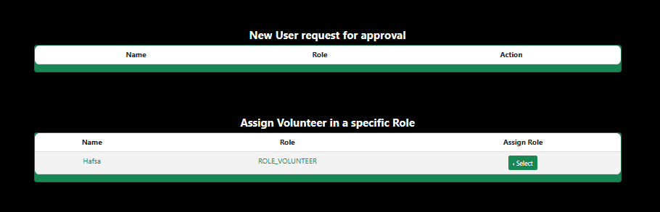

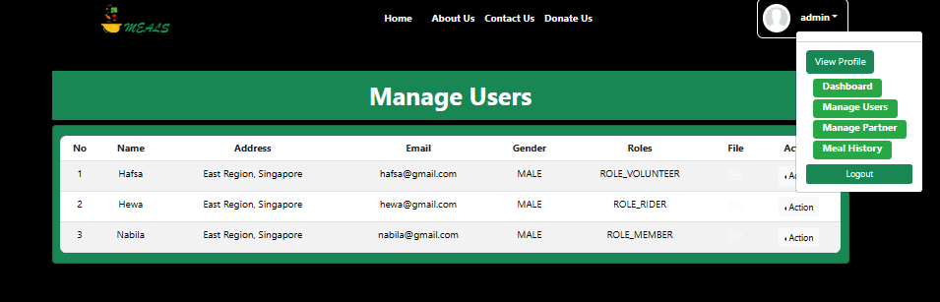

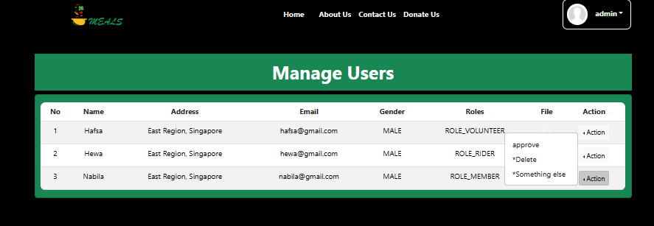

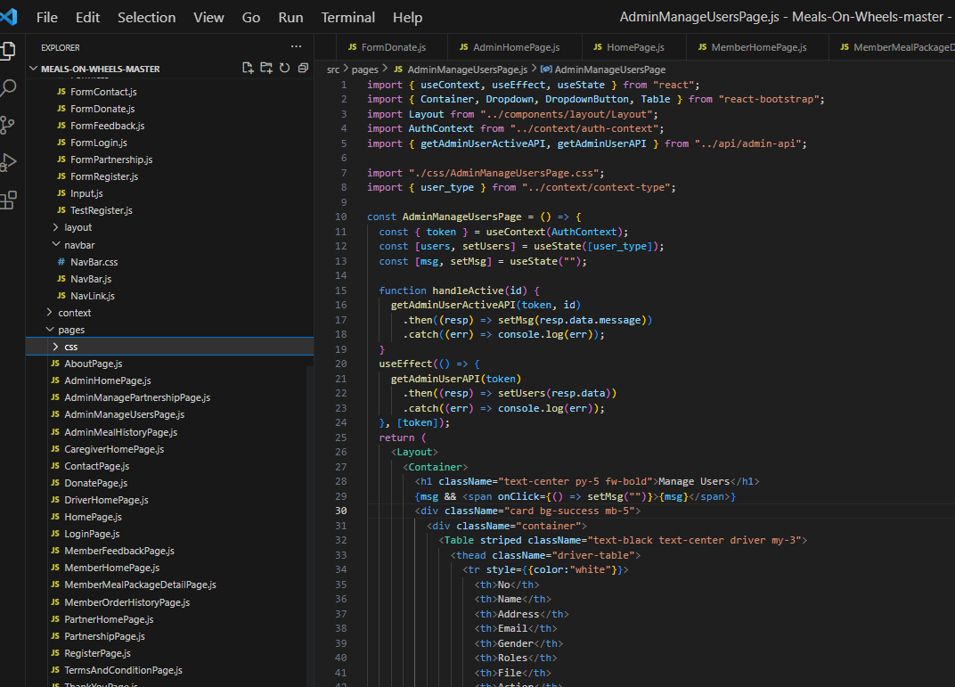

**Backend:**

**Controller:**

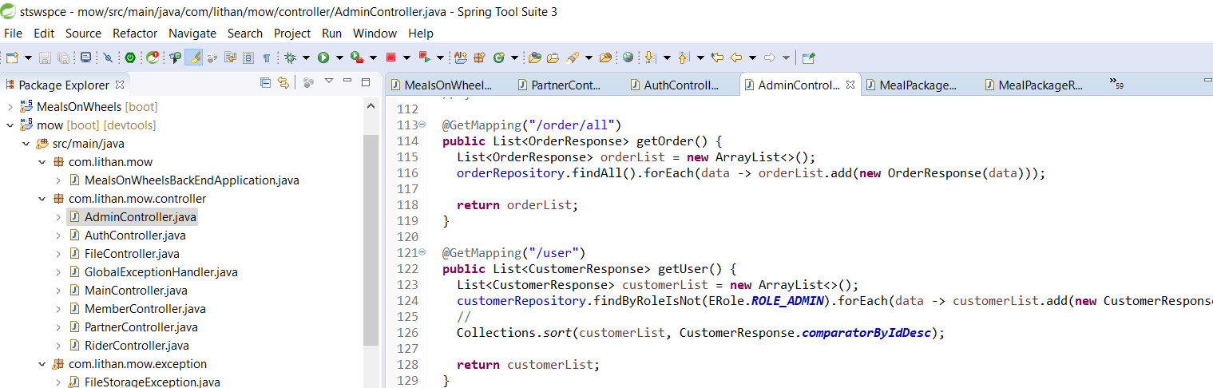

**Admin can manage partner:**

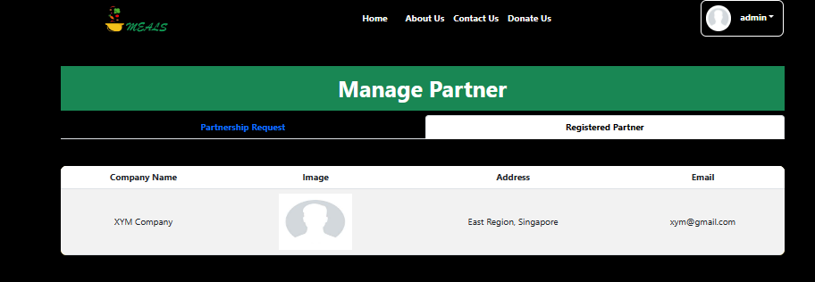

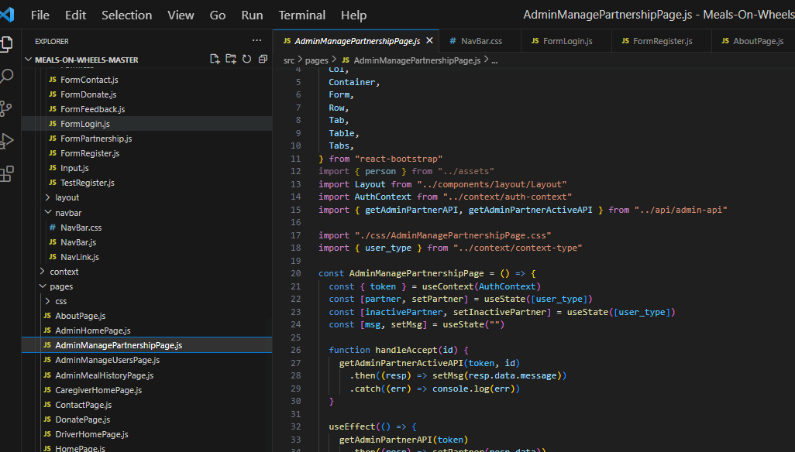

**Backend:**

**Controller:**

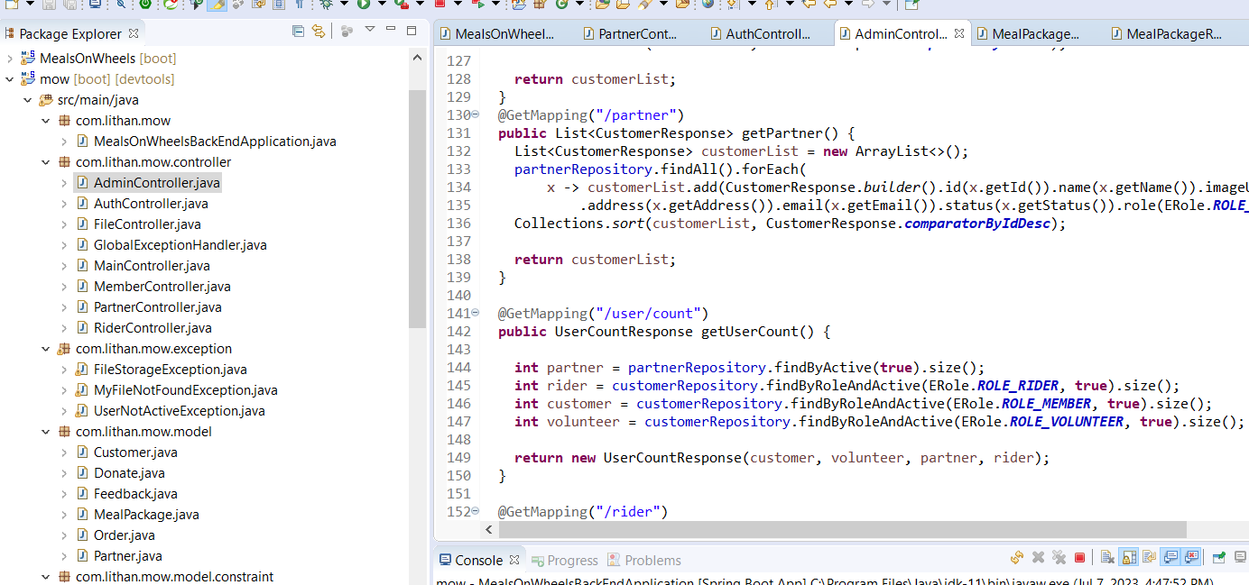

**Admin Can see and edit order request and order confirmation.**

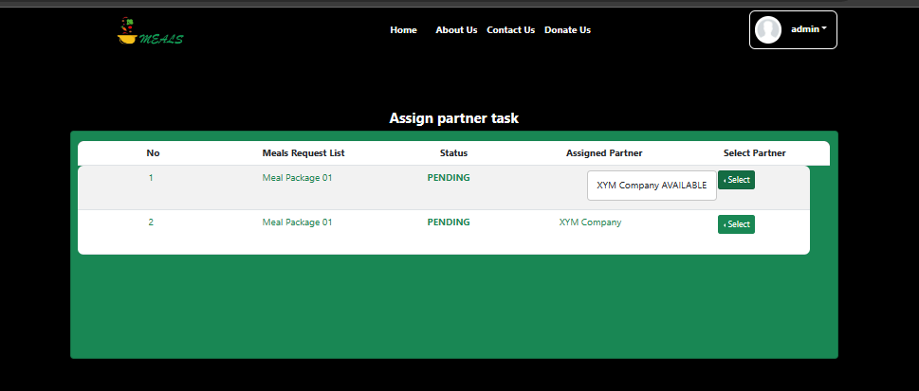

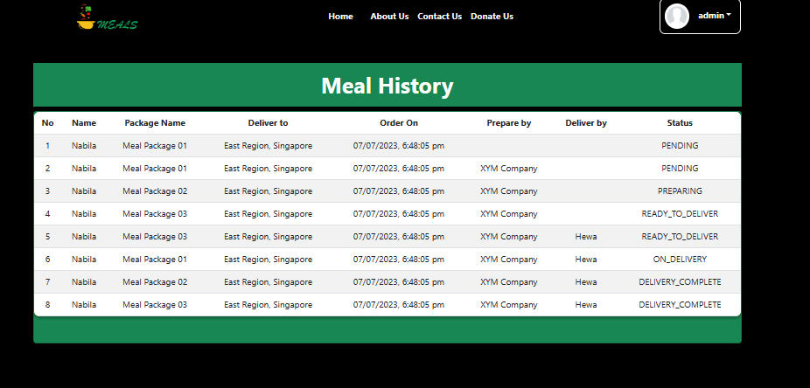

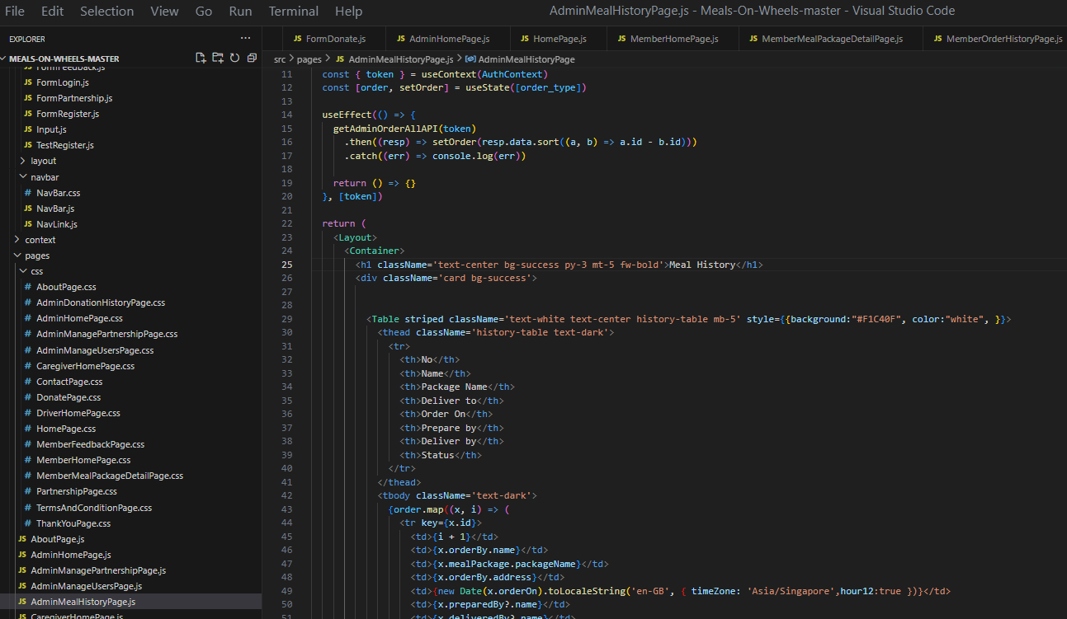

**Backend**

**Controller:**

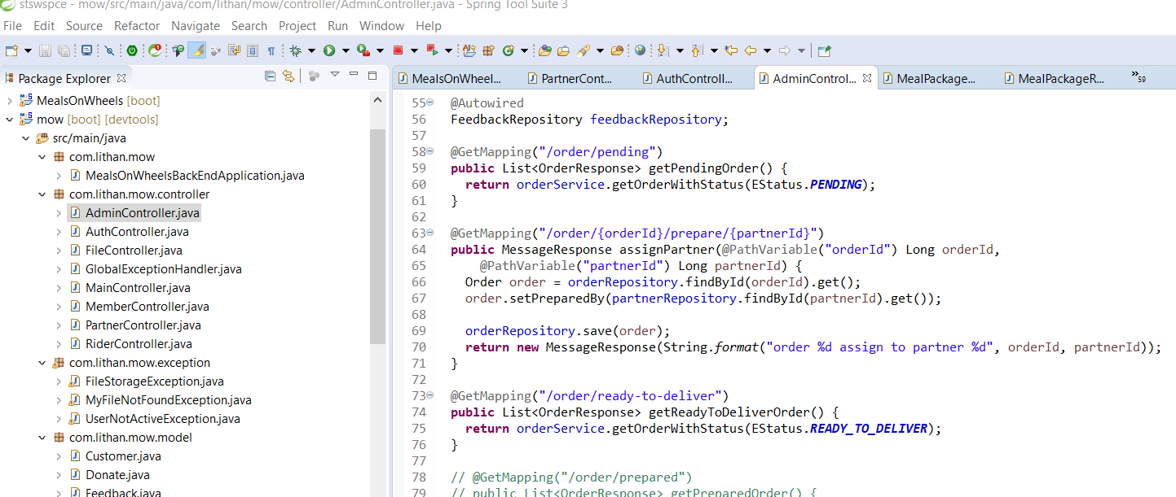

**Task 5: Project planning**

**5.0.1 WBS and Ghantt chart**

**Project Schedule:**

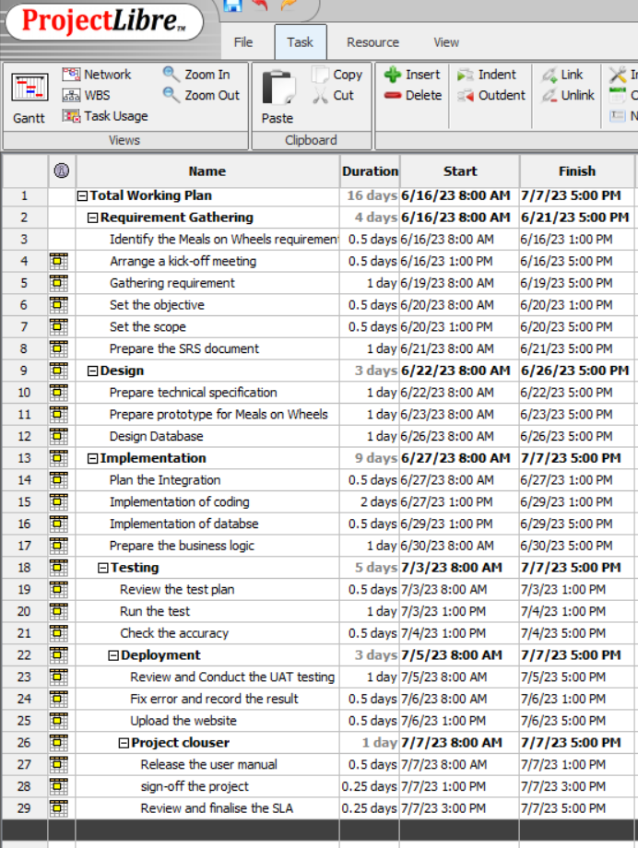

**Gantt Chart**

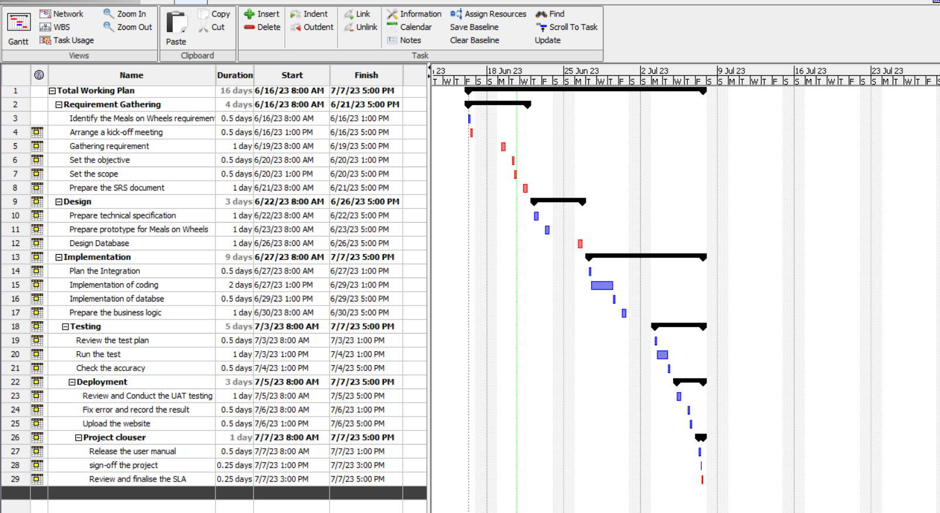

Detailed Plan – Individual – at the features level

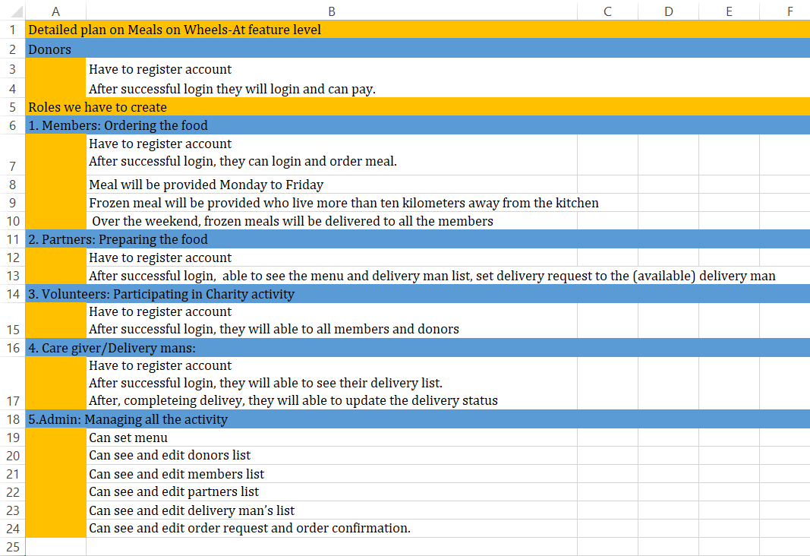

**Merry Meal Project Schedule: Project start:**

**Initiation phase**

* Business problem analysis
* Requirement elicitation and analysis with stake holders
* Framed SRS
* Projected aim, objective, scope
* Enlisted stakeholder
* Milestone plan
* Risk analysis

**Planning**

**Design plan:** Flowchart, story boards, wireframes

**Schedule plan:** WBS, Ghantt chart

**Resource plan:** Budget, Communication, testing

**Communication phase**

The Merry Meal project manager will speak with Merry Meal's employees and stakeholders to find out what they envision. After gathering the requirements, team will prepare a raw SRS document. The project manager will assign each team member their task and duties once the requirements and development plan have been finalized.

**Execution phase**

This is the beginning of the project's development based on the predevelopment stage. Every team member will implement their assigned task.

**Monitoring/ Controlling**

**Testing: UAT testing, Unit testing, performance testing, security testing**

Each time a team's iteration is finished, quality control will be performed by the Meals on Wheels developer team. QAT (Quality Assurance Testing) begins when the team will believe that a build or integration has been completed as per the build map. During this stage, team members will conduct testing based on defined scenarios and business requirements. The purpose is to ensure that the build meets the specified requirements and functions as intended and any scenarios that fall short are revised until the functionality meets the standards. Once all testing scenarios are successfully completed and meet the standards, the implementation is considered internally complete. Subsequently, the project progresses to the User Acceptance Testing (UAT) phase.

**Closure**

The deployment phase represents the final stage of the Meals on Wheels software development life cycle (SDLC), where the website will be transitioned into production. Once the project team has thoroughly tested the product and it has successfully passed each testing phase, it is deemed ready for implementation. This signifies that the product is prepared for real-world usage by end users. The deployment process encompasses several distinct phases, which the project team will follow to ensure the smooth deployment of code and technology. These phases include preparing for deployment, executing the deployment procedures, transferring ownership of the product, and concluding the deployment phase.

|  |  |  |
| --- | --- | --- |
| List of cost needed | Description of activity | Total cost in month |
| Requirement gathering | conducting market research, and identifying user needs, gathering and documenting the project requirements | $100 |
| Hardware | servers, storage devices, networking equipment, and related expenses | $1000 |
| Software | Spring Boot, React.js, postman (all are free software) | $100 |
| Hosting | GoDaddy (Cloud hosting) | $100 |
| Maintenance | maintenance, updates, and bug fixes, monitoring, security measures, and regular backups | $100 |
| Design Implementation | UI/UX design, graphic design, and frontend development using React.js | $300 |
| Human resource | salaries for the development team | $1000 |
| Marginal / urgent cost | for unforeseen expenses or urgent requirements that may arise during the development and deployment process | $100 |
| Total cost |  | $2800 |
| Total cost expected |  | $3000 |

5.0.2 **Budget Analysis**

* + 1. **Communication Matrix**

|  |  |  |  |  |
| --- | --- | --- | --- | --- |
| Speaker | Audience | Purpose | Medium | Frequency |
| Nabila Afsana | -stackholder  -Team | Show Member module working | Teams, email | daily |

* + 1. **Module test plans**
* **User Acceptance Testing**

|  |  |  |  |
| --- | --- | --- | --- |
| **Type of Testing** | **Test Scenario ID** | **Test Scenario** | **Number of Test Cases** |
| User acceptance testing | TS001 | Ensure that member can login to the website | 1 |
| TS002 | Ensure that member can view the meal details | 1 |
| TS003 | Ensure that member can send feed back | 1 |

|  |  |  |  |  |  |  |  |  |
| --- | --- | --- | --- | --- | --- | --- | --- | --- |
| **Scenario ID** | **Test Case ID** | **Test Case** | **Preconditions** | **Steps** | **Test Data** | **Expected Results** | **Actual Results** | **Pass/Fail** |
| TS001 | TC001 | Make sure member can login to the website. | Implementation of Meals on Wheels is completed with all webpages and navigation links and uploaded on local host server | 1. Enter URL localhost:3000  2. Sign in into the website as member. | [E-mail=nabila@gmail.com](mailto:E-mail=nabila@gmail.com)  Password=123456 | After successful login member should see the member dashboard. | As Excepted | Pass |
| **Evidence**  **Insert member email and password**  **Member will redirected to member dashboard** | | | | | | | | |
| TS002 | TC002 | Make sure member can view details of the meal. | Implementation of Meals on Wheels is completed with all webpages and navigation links and uploaded on local host server | 1. Enter URL localhost:3000  2. Sign in into the website as member  3.click on view details. | Mail meal=Vegetable plate  Drinks = peppermint Tea  Meal Details= Baked Apple | After click on view details member should see the details on the meal package | As Excepted | Pass |
| **Evidence**    **Click on view Details Details of the package** | | | | | | | | |
| TS003 | TC003 | Make sure member can send feedback. | Implementation of Meals on Wheels is completed with all webpages and navigation links and uploaded on local host server | 1. Enter URL localhost:3000  2. Sign in into the website as member.  3.in the dashboard click on feedback us.  4. After filling the details click on submit. | Name=nabila  E-mail= [nabila@gmail.com](mailto:nabila@gmail.com)  Package number =1  Feedback = Great Meal | Feedback form, details should be store in the database. | As Excepted | Pass |
| **Evidence**    **Click on feedback us Fill the details and click on submit**    **Feedback Detail successfully sored in the database.** | | | | | | | | |

* **Portability testing**

|  |  |  |  |
| --- | --- | --- | --- |
| **Type of Testing** | **Test Scenario ID** | **Test Scenario** | **Number of Test Cases** |
| Unit testing | TS001 | Open Merry Meal’s website on a Desktop | 1 |
| TS002 | Open Merry Meal’s website on a iPhone XR | 1 |
| TS003 | Open Merry Meal’s website on a iPad Mini | 1 |

|  |  |  |  |  |  |  |  |  |
| --- | --- | --- | --- | --- | --- | --- | --- | --- |
| **Scenario ID** | **Test Case ID** | **Test Case** | **Preconditions** | **Steps** | **Test Data** | **Expected Results** | **Actual Results** | **Pass/Fail** |
| TS001 | TC001 | To ensure all feature in the login page is visible to the user in Desktop | Implementation of Meals on Wheels is completed with all webpages and navigation links and uploaded on local host server. | 1. Enter URL localhost:3000 2. navigate to navigation bar 3. Click on login |  | After testing all login page feature is visible to the user in Desktop. | As Excepted | Pass |
| **Evidence** | | | | | | | | |
| TS002 | TC002 | To ensure all feature in the login page is visible to the user in Tablet | Implementation of Meals on Wheels is completed with all webpages and navigation links and uploaded on local host server. | 1. Enter URL localhost:3000 2. navigate to navigation bar 3. Click on login |  | After testing all login page feature is visible to the user in iPhone XR | As Excepted | Pass |
| **Evidence** | | | | | | | | |
| TS003 | TC003 | To ensure all feature in the login page is visible to the user in Smartphone | Implementation of Meals on Wheels is completed with all webpages and navigation links and uploaded on local host server. | 1. Enter URL localhost:3000 2. navigate to navigation bar 3. Click on login |  | After testing all login page feature is visible to the user in iPad Mini. | As Excepted | Pass |
| **Evidence** | | | | | | | | |

* **Compatibility testing**

|  |  |  |  |
| --- | --- | --- | --- |
| **Type of Testing** | **Test Scenario ID** | **Test Scenario** | **Number of Test Cases** |
| Unit testing | TS001 | Open login page using Microsoft Edge. | 1 |
| TS002 | Open login page using Mozilla Firefox. | 1 |
| TS003 | Open login page using Google Chrome. | 1 |

|  |  |  |  |  |  |  |  |  |
| --- | --- | --- | --- | --- | --- | --- | --- | --- |
| **Scenario ID** | **Test Case ID** | **Test Case** | **Preconditions** | **Steps** | **Test Data** | **Expected Results** | **Actual Results** | **Pass/Fail** |
| TS001 | TC001 | Check a consistent look and feel of the login page in Microsoft Edge | Implementation of Meals on Wheels is completed with all webpages and navigation links and uploaded on local host server | 1. Enter URL localhost:3000 on Microsoft Edge  2.Clcik on login | URL = localhost:3000/login | After testing login page maintain a consistent look and feel in Microsoft Edge. | As Excepted | Pass |
| **Evidence** | | | | | | | | |
| TS002 | TC002 | Check a consistent look and feel of the login page in Fire Fox. | Implementation of Meals on Wheels is completed with all webpages and navigation links and uploaded on local host server | 1. Enter URL localhost:3000 on Mozilla Firefox  2.Clcik on login | URL = localhost:3000/login | After testing login page maintain a consistent look and feel in Fire Fox. | As Excepted | Pass |
| **Evidence** | | | | | | | | |
| TS003 | TC003 | Check a consistent look and feel of the login page in Google Chrome | Implementation of Meals on Wheels is completed with all webpages and navigation links and uploaded on local host server | 1. Enter URL localhost:3000 on Google Chrome  2.Clcik on login. | URL = localhost:3000/login | After testing login page maintain a consistent look and feel in Google Chrome. | As Excepted | Pass |
| **Evidence** | | | | | | | | |

**Task 6: Project design**

**6.1. Application flowchart**

**Application Flowcharts**

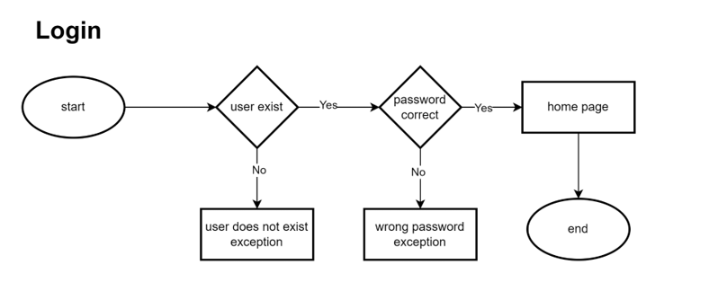

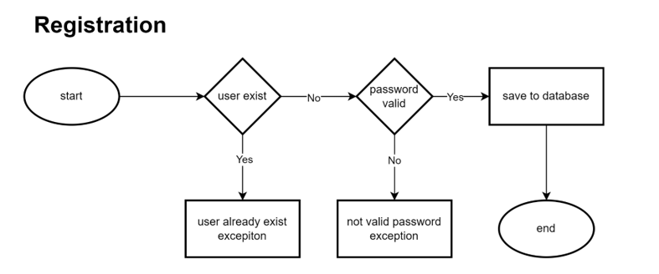

**Member**

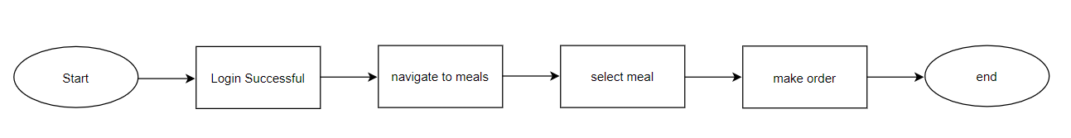

**Partner/Care giver**

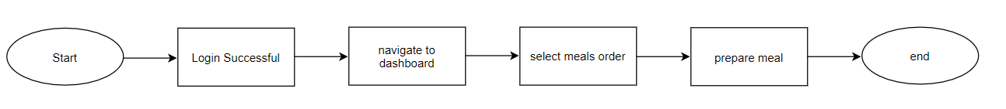

**Sponsor**

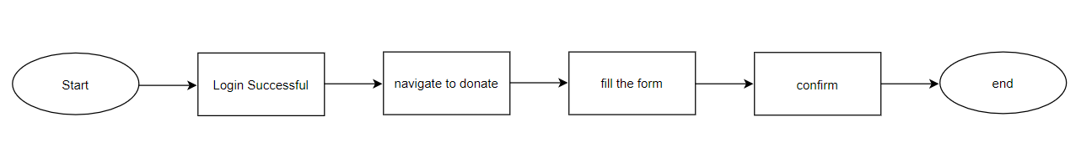

**Volunteer**

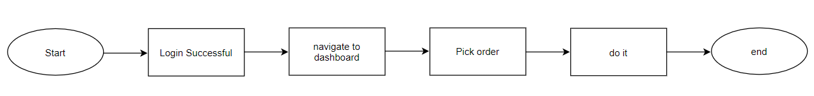

**Rider:**

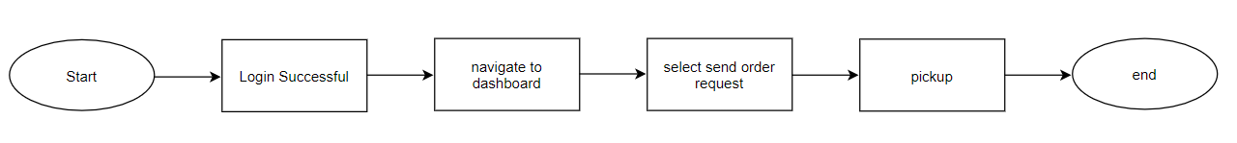

**6.3. Module Wireframes(individually based on module)**

**M01: 1. Partners registration with their details**

**Frontend:**



**Partner HomePage:**



**Partner Dashboard:**



**M01: 2. Member and Caregivers registration with their requirements**



**M02: 1. 1. Fund raising through donors/supporters**

**Frontend:**



**Fill Up the information and pay**



**M03: 1: 1. Menu Planning and Preparation**

**From Partner Side:** After successful login**,** on the partner dashboard, partner can see today’s Meal package list and Order Status.



**Menu List From Member Side:**





**M03: 2. Meal Delivery Management of partners and riders**

After confirming delivery, partner can update the delivery status in the below section.



**Rider Delivery Management:** Rider can update Rider availability status and also update delivery status on the marked sections.



**M04. 1. Admin access for managing all backend works**

**Admin can assign partner task:**



**Admin can set menu:**

By clicking on Add Meal button admin will get the set menu form.



**Admin will insert all the menu list and by clicking on submit menu will be set.**



**Created meal package**



**Admin can manage member, rider, volunteer:**







**Admin can manage partner:**



**Admin Can see and edit order request and order confirmation.**





**6.4. Module storyboard**

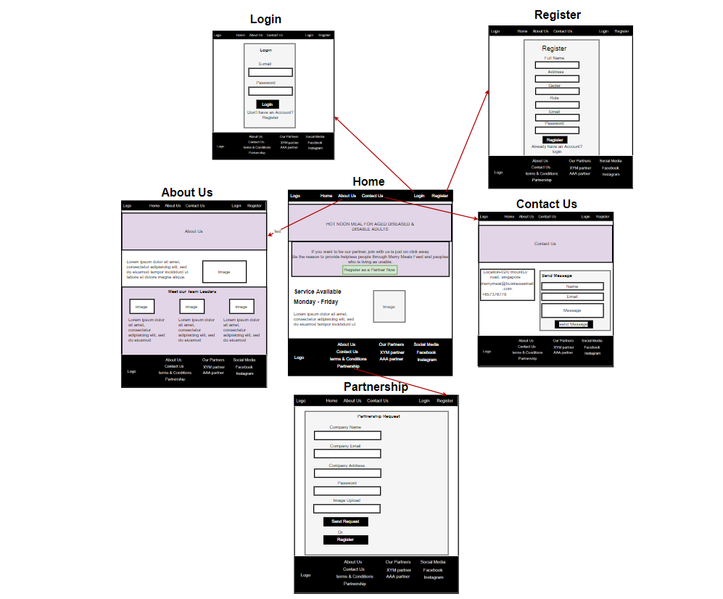

**7.0 Project Stakeholder presentation**

(Stakeholders review statements and document their feedback)

|  |  |  |  |  |
| --- | --- | --- | --- | --- |
| Stakeholder | Specific Areas to be improved | Actions to be taken to improve performance | Progress Status (Achieved and not achieved) | Screen capture ID (improvised design page) |
| Sr. Manager from Unity One solution, Merry Mealrepresentatives | Partnership registration form they want to separate it from other user registration form. | So, in backend we create separate model, controller, repository and in frontend we create separate partner registration form. | achieved |  |
| Sr. Manager from Unity One solution, Merry Meal representatives | Initially partner could not update the order status | We develop partner controller, give the order access control in backend. | achieved |  |
| Sr. Manager from Unity One solution, Merry Meal representatives | Initially Rider availability status was not available in frontend | We develop rider controller, give the access to the rider, so that rider can update the availability | achieved |  |

**Observation And Witness Records:**

**8.0 Project execution: individual-module-wise: evidence**

(Application **Module** screen shots+ source code screen captures)

**M01: 1. Partners registration with their details**

**Frontend:**





**Database:**



**Backend:**

**Model**



**Controller:**



**Repository:**



**Partner HomePage:**





**Partner Dashboard:**



**M01: 2. Member and Caregivers registration with their requirements**





**Database:**



**Backend:**

**Model**



**Auth Controller:**



**Role Repository:**



**M02: 1. 1. Fund raising through donors/supporters**

**Frontend:**





**Fill Up the information and pay**



**Backend:**

**Model:**



**Repository:**



**Request:**



**M03: 1: 1. Menu Planning and Preparation**

**From Partner Side:** After successful login**,** on the partner dashboard, partner can see today’s Meal package list and Order Status.





**Backend:**

**Controller**



**Menu List From Member Side:**





**Backend**

**Controller**



**Model:**



**M03: 2. Meal Delivery Management of partners and riders**

After confirming delivery, partner can update the delivery status in the below section.



**Controller**



**Rider Delivery Management:** Rider can update Rider availability status and also update delivery status on the marked sections.



**M04. 1. Admin access for managing all backend works**

**Admin can assign partner task:**





**Backend:**



**Admin can set menu:**

By clicking on Add Meal button admin will get the set menu form.



**Admin will insert all the menu list and by clicking on submit menu will be set.**







**Backend:**

**Model:**



**Controller:**



**Repository:**



**Admin can manage member, rider, volunteer:**









**Backend:**

**Controller:**



**Admin can manage partner:**





**Backend:**

**Controller:**



**Admin Can see and edit order request and order confirmation.**







**Backend**

**Controller:**



**Home Page:**

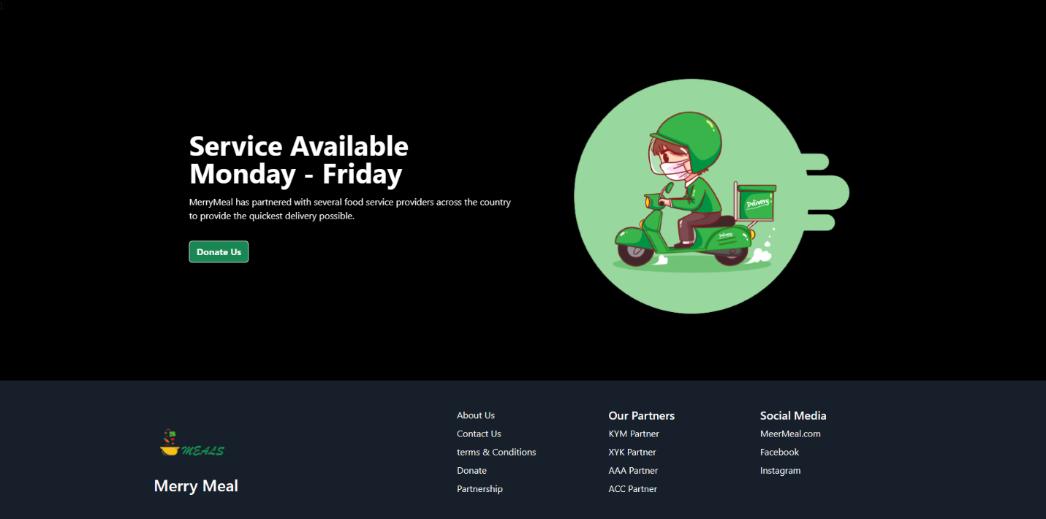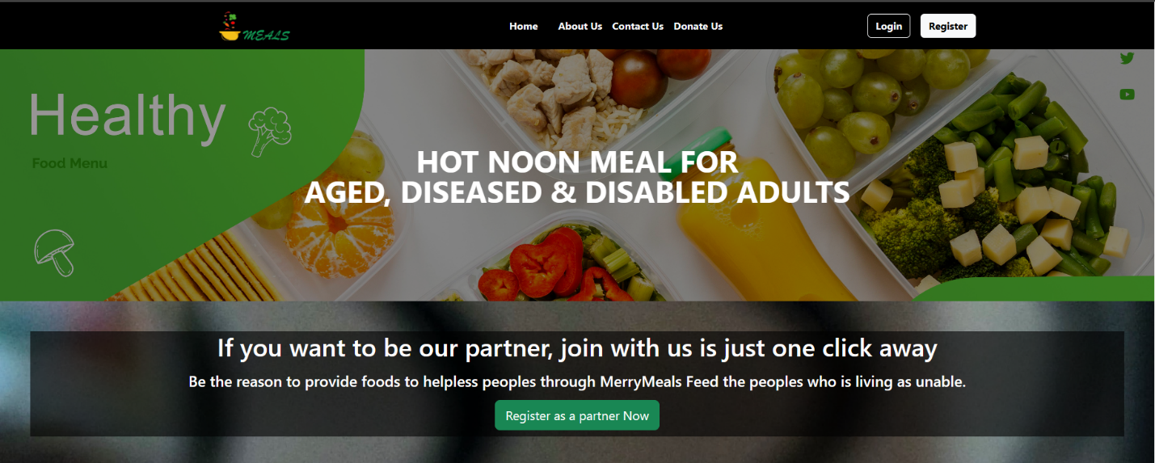

**About Us Page:**

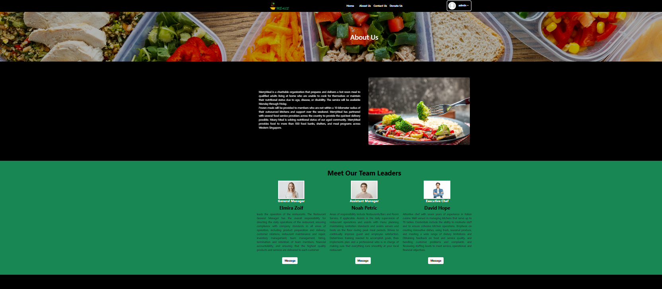

**Contact Us:**

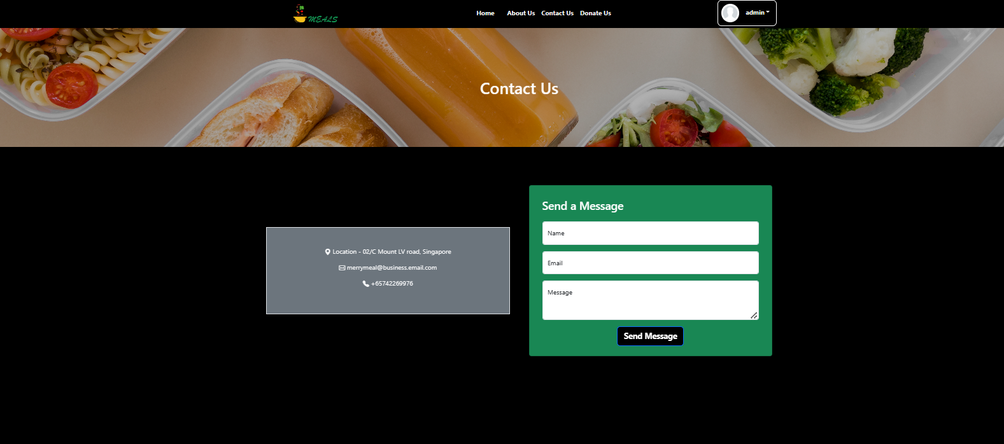

**Task 9: Testing**

**Portability testing**

|  |  |  |  |
| --- | --- | --- | --- |
| **Type of Testing** | **Test Scenario ID** | **Test Scenario** | **Number of Test Cases** |
| Unit testing | TS001 | Open Merry Meal’s website on a Desktop | 1 |
| TS002 | Open Merry Meal’s website on a iPhone XR | 1 |
| TS003 | Open Merry Meal’s website on a iPad Mini | 1 |

|  |  |  |  |  |  |  |  |  |
| --- | --- | --- | --- | --- | --- | --- | --- | --- |
| **Scenario ID** | **Test Case ID** | **Test Case** | **Preconditions** | **Steps** | **Test Data** | **Expected Results** | **Actual Results** | **Pass/Fail** |
| TS001 | TC001 | To ensure all feature in the login page is visible to the user in Desktop | Implementation of Meals on Wheels is completed with all webpages and navigation links and uploaded on local host server. | 1. Enter URL localhost:3000 2. navigate to navigation bar 3. Click on login |  | After testing all login page feature is visible to the user in Desktop. | As Excepted | Pass |
| **Evidence** | | | | | | | | |
| TS002 | TC002 | To ensure all feature in the login page is visible to the user in Tablet | Implementation of Meals on Wheels is completed with all webpages and navigation links and uploaded on local host server. | 1. Enter URL localhost:3000 2. navigate to navigation bar 3. Click on login |  | After testing all login page feature is visible to the user in iPhone XR | As Excepted | Pass |
| **Evidence** | | | | | | | | |
| TS003 | TC003 | To ensure all feature in the login page is visible to the user in Smartphone | Implementation of Meals on Wheels is completed with all webpages and navigation links and uploaded on local host server. | 1. Enter URL localhost:3000 2. navigate to navigation bar 3. Click on login |  | After testing all login page feature is visible to the user in iPad Mini. | As Excepted | Pass |
| **Evidence** | | | | | | | | |

**Compatibility testing**

|  |  |  |  |
| --- | --- | --- | --- |
| **Type of Testing** | **Test Scenario ID** | **Test Scenario** | **Number of Test Cases** |
| Unit testing | TS001 | Open login page using Microsoft Edge. | 1 |
| TS002 | Open login page using Mozilla Firefox. | 1 |
| TS003 | Open login page using Google Chrome. | 1 |

|  |  |  |  |  |  |  |  |  |
| --- | --- | --- | --- | --- | --- | --- | --- | --- |
| **Scenario ID** | **Test Case ID** | **Test Case** | **Preconditions** | **Steps** | **Test Data** | **Expected Results** | **Actual Results** | **Pass/Fail** |
| TS001 | TC001 | Check a consistent look and feel of the login page in Microsoft Edge | Implementation of Meals on Wheels is completed with all webpages and navigation links and uploaded on local host server | 1. Enter URL localhost:3000 on Microsoft Edge  2.Clcik on login | URL = localhost:3000/login | After testing login page maintain a consistent look and feel in Microsoft Edge. | As Excepted | Pass |
| **Evidence** | | | | | | | | |
| TS002 | TC002 | Check a consistent look and feel of the login page in Fire Fox. | Implementation of Meals on Wheels is completed with all webpages and navigation links and uploaded on local host server | 1. Enter URL localhost:3000 on Mozilla Firefox  2.Clcik on login | URL = localhost:3000/login | After testing login page maintain a consistent look and feel in Fire Fox. | As Excepted | Pass |
| **Evidence** | | | | | | | | |
| TS003 | TC003 | Check a consistent look and feel of the login page in Google Chrome | Implementation of Meals on Wheels is completed with all webpages and navigation links and uploaded on local host server | 1. Enter URL localhost:3000 on Google Chrome  2.Clcik on login. | URL = localhost:3000/login | After testing login page maintain a consistent look and feel in Google Chrome. | As Excepted | Pass |
| **Evidence** | | | | | | | | |

**User Acceptance Testing**

|  |  |  |  |
| --- | --- | --- | --- |
| **Type of Testing** | **Test Scenario ID** | **Test Scenario** | **Number of Test Cases** |
| User acceptance testing | TS001 | Ensure that member can login to the website | 1 |
| TS002 | Ensure that member can view the meal details | 1 |
| TS003 | Ensure that member can send feed back | 1 |

|  |  |  |  |  |  |  |  |  |
| --- | --- | --- | --- | --- | --- | --- | --- | --- |
| **Scenario ID** | **Test Case ID** | **Test Case** | **Preconditions** | **Steps** | **Test Data** | **Expected Results** | **Actual Results** | **Pass/Fail** |
| TS001 | TC001 | Make sure member can login to the website. | Implementation of Meals on Wheels is completed with all webpages and navigation links and uploaded on local host server | 1. Enter URL localhost:3000  2. Sign in into the website as member. | [E-mail=nabila@gmail.com](mailto:E-mail=nabila@gmail.com)  Password=123456 | After successful login member should see the member dashboard. | As Excepted | Pass |
| **Evidence**  **Insert member email and password**  **Member will redirected to member dashboard** | | | | | | | | |
| TS002 | TC002 | Make sure member can view details of the meal. | Implementation of Meals on Wheels is completed with all webpages and navigation links and uploaded on local host server | 1. Enter URL localhost:3000  2. Sign in into the website as member  3.click on view details. | Mail meal=Vegetable plate  Drinks = peppermint Tea  Meal Details= Baked Apple | After click on view details member should see the details on the meal package | As Excepted | Pass |
| **Evidence**    **Click on view Details Details of the package** | | | | | | | | |
| TS003 | TC003 | Make sure member can send feedback. | Implementation of Meals on Wheels is completed with all webpages and navigation links and uploaded on local host server | 1. Enter URL localhost:3000  2. Sign in into the website as member.  3.in the dashboard click on feedback us.  4. After filling the details click on submit. | Name=nabila  E-mail= [nabila@gmail.com](mailto:nabila@gmail.com)  Package number =1  Feedback = Great Meal | Feedback form, details should be store in the database. | As Excepted | Pass |
| **Evidence**    **Click on feedback us Fill the details and click on submit**    **Feedback Detail successfully sored in the database.** | | | | | | | | |

**Test Analysis :** discuss results in detail and explain module outcomes are meeting the initial set objectives of the application.

**Conclusion: Area for Improvements:**

We have to improve admin order status update portion.

Our Meal delivery system is not much advanced. We have to use Google map for delivering the order.

As we are now at learning face, there are lacking fine-tuning in the overall project.

**Application Future recommendations:**